 |  | 
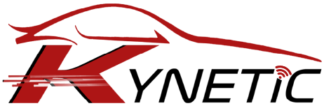
MANSOURA UNIVERSITY
FACULTY OF ENGINEERING
Mechatronics ENGINEERING Program
A Modular Smart Transportation System Using Software-Defined Vehicles In Smart Cities
Project Members | ID Number
Ahmed Tolba El-Bayoumi Tolba | 805538033
Mohammed Ahmed Mohammed Awad Ali Tarabay | 805494116
Mahmoud Mohamed Ibrahim Mahgoup | 806143446
Ahmed Mahmoud Abdelfattah Fahmy | 805536417
Fady Nasrallah Manas Nasr | 806087898
Ahmed Mohammed Mohammed Hammad | 805494115
Mohammed Ibrahim Abdelmaksoud | 806095112
Abdelrahman Mohamed Gawish | 806235415
Khaled Metwally Saad Elkon | 800126912

Project Supervisors
Assoc. Prof. Abeer Twakol Khalil
Eng. Ahmed Semida
Academic Year: 2025 – 2026
January 2026
 |  | 

جامعة المنصورة
كلية الهندسة
برنامج هندسة الميكاترونكس
نظام نقل مُعياري يدمج المركبات المعرفة برمجيًا في المدن الذكية
805538033 | احمد طلبة البيومى طلبة
805494116 | محمد احمد محمد عوض علي طرباي
806143446 | محمود محمد ابراهيم محمد محجوب
805536417 | احمد محمود عبد الفتاح فهمي العدل
806087898 | فادي نصرالله مناس نصر
805494115 | احمد محمد محمد حماد فوده
806095112 | محمد ابراهيم عبد المقصود احمد عمر
806235415 | عبد الرحمن محمد جاويش
800126912 | خالد متولي سعد المتولي القن
المشرفين علي المشروع
استاذ مساعد دكتور / عبير توكل خليل
مهندس / احمد جمال صميده
العام الاكاديمي : 2025 - 2026
يناير 2026

ABSTRACT
The emergence of smart cities represents a significant advancement in urban development, characterized by the integration of data, connectivity, and intelligent infrastructure. As urban populations expand and mobility requirements intensify, conventional transportation systems increasingly fail to address contemporary demands. In response, smart cities seek to merge technological innovation with urban planning to establish safer, more efficient, and environmentally sustainable mobility networks. Central to this transformation is the Software-Defined Vehicle (SDV), a concept that relocates vehicle intelligence from fixed hardware to flexible, updatable software architectures.
This project articulates a comprehensive framework for a transportation system in smart cities based on Software-Defined Vehicle (SDV) principles. The proposed system conceptualizes vehicles as interconnected digital entities capable of communication, learning, and adaptation. By redefining vehicle functionality through software, SDVs facilitate ongoing improvement, remote updates, and adaptive performance that aligns with evolving urban conditions. This approach enables cities to manage vehicle fleets more efficiently, decrease maintenance expenditures, and implement new mobility services without significant physical alterations.
The proposed model prioritizes seamless interaction among vehicles, infrastructure, and central control systems. It outlines a transportation network in which real-time data exchange improves traffic coordination, resource allocation, and safety management. This integration positions transportation as an adaptive component of the urban environment, responsive to and aligned with the broader digital ecosystem.
In addition to its technical potential, the project highlights the broader social and environmental benefits of transportation systems based on Software-Defined Vehicle (SDV) technology. By supporting cleaner, more efficient mobility, SDVs contribute to sustainability objectives and the advancement of intelligent urban environments. This work demonstrates that software-defined mobility can connect engineering innovation with societal development, establishing a foundation for future smart transportation systems that address both human and environmental needs.

ACKNOWLEDGEMENTS
We would like to express our deepest gratitude to all those who supported and guided us throughout the journey of this graduation project and our academic years.
First and foremost, we extend our heartfelt appreciation to our families and friends for their unwavering encouragement, patience, and continuous support. Their belief in us has been the driving force behind every step of our progress. Without their love, understanding, and motivation, this achievement would not have been possible.
We would like to express our sincere gratitude to Assoc. Prof. Abeer Twakol Khalil, our supervisor, for her invaluable guidance, insightful feedback, and constant encouragement. Her expertise, patience, and mentorship have been instrumental in shaping both this project and our understanding of the field. Her support inspired us to approach every challenge with determination and curiosity, helping us transform our ideas into a tangible and meaningful achievement.
Our special thanks also go to Eng. Ahmed Semida for his exceptional assistance and contribution in developing the ADAS module. His technical insights, practical experience, and dedicated guidance played a major role in elevating the quality of our work. His willingness to help and share knowledge truly reflects the collaborative spirit that drives innovation.
We are also deeply thankful to the Artificial Intelligence Engineering Program for their collaboration, cooperation, and continuous support in facilitating this project. The program’s resources, workshops, and academic environment have provided us with the tools and opportunities to grow both academically and personally.
Furthermore, we wish to extend our appreciation to all our professors, teaching assistants, and mentors who have guided us over the past five years. Their dedication, knowledge, and passion for teaching have inspired us to strive for excellence and to carry forward the values of integrity, curiosity, and perseverance. Each of them has contributed in shaping us into who we are today — future engineers ready to take on real-world challenges with confidence and purpose.
As we reach the conclusion of this journey, we look back with immense gratitude for every lesson learned and every challenge overcome. This project stands as a testament not only to our technical skills but also to our teamwork, patience, and determination. It marks the transition from students to professionals, and we are proud to carry forward the knowledge, values, and experiences gained during our years at Mansoura University into the next chapter of our lives.
TABLE OF CONTENTS
ABSTRACT II
ACKNOWLEDGEMENTS III
LIST OF FIGURES VIII
LIST OF TABLES IX
LIST OF ABBREVIATIONS X
1 Chapter (1) Introduction 1
1.1 Background 1
1.2 Motivation 2
1.3 Problem Definition 3
1.4 Objectives 5
1.4.1 SDV with OTA Updates 5
1.4.2 ADAS Implementation 5
1.4.3 Secure V2X Communication 5
1.4.4 Vehicle–Infrastructure Integration 6
1.4.5 Scalability and Interoperability 6
1.4.6 Research and Innovation 6
1.5 Scope and Limitations 6
2 Chapter (2) Literature Review 8
2.1 Introduction 8
2.2 Smart Transportation Systems 9
2.3 Software-Defined Vehicles (SDVs) 10
2.4 Advanced Driver-Assistance Systems (ADAS) 12
2.5 Vehicle-to-Everything (V2X) Communication 13
2.6 Automotive Cybersecurity 14
2.7 Over-the-Air (OTA) Update Systems 15
2.8 Smart Infrastructure and Urban Integration 17
2.9 Summary 18
3 Chapter (3) Mechanical Design & Fabrication 20
4 Chapter (4) Hardware & Tools 21
4.1 Introduction 21
4.2 Raspberry Pi 5 22
4.2.1 Specifications 22
4.2.2 Description 23
4.2.3 Usage 24
4.3 ATmega32A 25
4.3.1 Specifications 25
4.3.2 Description 26
4.3.3 Usage 27
4.4 IMU Sensor (MPU9250) 28
4.4.1 Specifications 28
4.4.2 Description 29
4.4.3 Usage 30
4.5 Ultrasonic Sensor 31
4.5.1 Specifications 31
4.5.2 Description 31
4.5.3 Usage 32
4.6 LCD 20x4 34
4.6.1 Specifications 34
4.6.2 Description 34
4.6.3 Usage 35
4.7 GPS (Ublox NEO-6M) 37
4.7.1 Specifications 37
4.7.2 Description 37
4.7.3 Usage 38
4.8 ESP32 41
4.8.1 Specifications 41
4.8.2 Description 42
4.8.3 Usage 43
4.9 Raspberry Pi Camera v2 45
4.9.1 Specifications 45
4.9.2 Description 46
4.9.3 Usage 47
4.10 Xbox 360 Kinect Camera 49
4.10.1 Specifications 49
4.10.2 Description 49
4.10.3 Usage 51
5 Chapter (5) Software & Workflow 52
6 Chapter (6) Business Study 53
6.1 Introduction 53
6.2 Market Analysis 54
6.2.1 Global Software-Defined Vehicle (SDV) Market 54
6.2.2 Mobility as a Service (MaaS) Market 55
6.3 Business Model 58
6.3.1 Key Partners 59
6.3.2 Key Activities 59
6.3.3 Key Resources 60
6.3.4 Value Proposition 61
6.3.5 Customer Relationship 62
6.3.6 Channels 62
6.3.7 Customer Segments 63
6.3.8 Cost Structure 64
6.3.9 Revenue Streams 65
6.4 SWOT Analysis 67
6.4.1 Strengths 67
6.4.2 Weaknesses 68
6.4.3 Opportunities 68
6.4.4 Threats 69
6.5 Sustainable Development Goals 69
6.5.1 SDG 8 – Decent Work and Economic Growth 70
6.5.2 SDG 9 – Industry, Innovation, and Infrastructure 70
6.5.3 SDG 11 – Sustainable Cities and Communities 70
6.6 Egypt Vision 2030 and Digital Transformation 71
7 Chapter (7) Conclusion 73
8 Chapter (8) Future Work 75
8.1 Introduction 75
8.2 Implementation of EV 76
8.2.1 Simulations of MATLAB EV Design with Simscape 77
8.3 Vehicle-to-Grid (V2G) Communication 81
8.4 More Optimized and Accurate Visual Perception using LiDAR 82
8.5 Enhanced FOTA/SOTA Delivery using FogNet and Roadside Units (RSU) 83
8.6 Implementing Additional Computer Vision Models in ADAS 85
8.7 Enhancing the Ride Booking Mobile Application with V2I Communication 86
8.8 Enhancing the Interfaces of the Ride Booking App using Figma 87
8.9 Implementing Embedded Linux 88
References 90
APPENDICES 94
Appendix A. 94
Appendix B. 95

LIST OF FIGURES
Figure ‎4-1: Raspberry Pi 5 22
Figure ‎4-2: ATmega32A 25
Figure ‎4-3: MPU9250 28
Figure ‎4-4: Ultrasonic Sensor 31
Figure ‎4-5: LCD 20x4 34
Figure ‎4-6: Ublox NEO-6m GPS Module 37
Figure ‎4-7: ESP32 41
Figure ‎4-8: Raspberry Pi Camera v2 45
Figure ‎4-9: Xbox 360 Kinect Camera 49
Figure ‎6-1: Market Analysis For SDV Market 55
Figure ‎6-2: Market Analysis for Mobility as a Service Market 57
Figure ‎6-3: SDGs for the Project 69
Figure ‎6-4: Egypt Vision 2030 71
Figure ‎8-1: Design of the electric propulsion systems 77
Figure ‎8-2: Drive Range Estimator Model 77
Figure ‎8-3: Size Battery Model 78
Figure ‎8-4: Battery Characterization Using HPPC Test Data 78
Figure ‎8-5: Visualization of Neural Network Model That Predicts Battery Temprature 79
Figure ‎8-6: Efficient Gear Ratio For Electric Drive DoE 79
Figure ‎8-7: Electric Motor Test Bench For System Integration Model 80
Figure ‎8-8: Electric Drive Durability and Life Verification Model 80
Figure ‎8-9: Vehicle-to-Grid (V2G) Communication Methodology 81
Figure ‎8-10: LiDAR Point Cloud Coordinate Reference 82
Figure ‎8-11: Roadside Unit Deployment 84
Figure ‎8-12: FogNet vs Cloud Computing Architecture 85
Figure ‎8-13: ADAS Structure 85
Figure ‎8-14: Figma 87
Figure ‎8-15: Linux 88

LIST OF TABLES
Table ‎4-1: Raspberry Pi 5 Specifications 22
Table ‎4-2: ATmega32A Specifications 25
Table ‎4-3: MPU9250 Specifications 28
Table ‎4-4: Ultrasonic Specifications 31
Table ‎4-5: LCD Specifications 34
Table ‎4-6: Ublox NEO-6m GPS Module Specifications 37
Table ‎4-7: ESP32 Specifications 41
Table ‎4-8: Raspberry Pi Camera v2 Specifications 45
Table ‎4-9: Xbox 360 Kinect Camera Specifications 49
Table ‎6-1: Business Model for the Project 58
Table ‎6-2: SWOT Analysis For the Project 67

LIST OF ABBREVIATIONS
SDV | Software-Defined Vehicle
ADAS | Advanced Driver Assisstance System
OTA | Over-The-Air
AI | Artificial Intelligence
CV | Computer Vision
IoT | Internet Of Things
ITS | Intelligent Transportation System
FOTA | Firmware Over-The-Air
GPS | Global Positioning System
SOTA | Software Over-the-Air
V2I | Vehicle-to-Infrastructure
V2V | Vehicle-to-Vehicle
V2X | Vehicle-to-Everything
ECU | Electronic Control Unit
EV | Electric Vehicle
V2G | Vehicle-to-Grid
BMC | Business Model Canvas
SDG | Sustainable Development Goals
ONNX | Open Neural Network Exchange
SCNN | Spatial Convolutional Neural Network
ENet | Efficient Neural Network
ENet-SAD | Efficient Neural Network with Self-Attention Distillation
V2P | Vehicle-to- Pedestrian
GPU | Graphic Processing Unit
TPU | Tensor Processing Unit
NPU | Neural Processing Unit
CPS | Cyber-Physical Systems
LPDDR4X | Low Power Double Data Rate 4X (type of RAM)
Wi-Fi | Wireless Fidelity
USB | Universal Serial Bus
MIPI | Mobile Industry Processor Interface
CSI | Camera Serial Interface
GPIO | Universal Serial Bus Type-C
AVR | Advanced Virtual RISC
RISC | Reduced Instructions Set Computer
I/O | Input/Output
UART | Universal Asynchronous Receiver/Transmitter
SPI | Serial Peripheral Interface
I2C | Inter-Integrated Circuit
ADC | Analog-to-Digital Converter
PWM | Pulse Width Modulation
DIP | Dual In-line Package
TQFP | Thin Quad Flat Package
IMU | Inertial Measurement Unit
DoF | Degrees of Freedom
MPU | Motion Processing Unit
DMP | Digital Motion Processor
SRAM | Static Random-Access Memory
EEPROM | Electrically Erasable Programmable Read-Only Memory
LCD | Liquid Crystal Display
DoE | Design of Experiment
MaaS | Mobility as a Service

CHAPTER 1
INtroduction

Chapter (1) Introduction

Background
The traditional transportation paradigm — characterized by isolated vehicles and static infrastructure — has shifted toward intelligent systems capable of dynamic interaction and automated decision-making.
At the heart of this transformation lies the IoT, which connects millions of devices, sensors, and vehicles through high-speed communication networks [2]. This interconnected environment enables the continuous exchange of real-time information between vehicles, infrastructure, and control centers, leading to improved traffic management, reduced congestion, and enhanced safety. IoT-enabled platforms allow authorities to monitor road conditions, detect accidents, optimize traffic light cycles, and predict travel patterns through advanced analytics.
Moreover, smart transportation infrastructure has become the backbone of smart mobility. Roads, bridges, and intersections are now equipped with embedded sensors and communication modules that interact with vehicles and central management systems [3]. These smart infrastructures facilitate V2I communication, allowing vehicles to receive timely information about road hazards, speed limits, and environmental conditions [4]. In turn, these developments contribute to smoother traffic flow, lower emissions, and better energy management within urban environments [5].
However, the ongoing digital transformation of cities introduces new complexities. As transportation becomes more reliant on software and network connectivity, vehicles are evolving from purely mechanical systems into SDVs. These vehicles represent a major leap forward in automotive innovation, allowing for OTA updates, ADAS, and robust cybersecurity frameworks. SDVs redefine how vehicles are maintained, upgraded, and secured, ensuring that safety-critical functions can be enhanced without requiring physical intervention.
This convergence of smart infrastructure, intelligent vehicles, and digital connectivity forms the cornerstone of modern transportation in smart cities. The integration of IoT, AI, and cloud computing technologies enables vehicles to operate autonomously, respond intelligently to environmental changes, and communicate cooperatively with one another and with surrounding infrastructure. In essence, transportation in smart cities is not just about movement — it is about creating a seamless, adaptive, and sustainable mobility ecosystem that embodies the principles of innovation, resilience, and human-centered design.

Motivation
For decades, traditional vehicles have been hardware-defined systems, where functionality was largely determined at the time of manufacture. Enhancements or repairs required physical intervention, such as replacing mechanical components or reprogramming ECUs manually. This rigid structure limited innovation and slowed the pace of technological adaptation within the automotive industry. However, the increasing complexity of modern transportation systems — driven by automation, connectivity, and data intelligence — has necessitated a fundamental shift in how vehicles are designed, operated, and maintained.
The emergence of autonomous and connected vehicles has introduced a new set of requirements that traditional architectures can no longer satisfy. These vehicles must continuously adapt to changing environments, learn from data, and receive software updates to improve safety, performance, and user experience. This evolution has led to the rise of the SDV paradigm, which places software at the core of vehicle functionality [21], [22]. By decoupling hardware from software, SDVs enable flexible, scalable, and remotely managed architectures. Centralized computing systems replace distributed ECUs, allowing vehicles to receive OTA and FOTA updates — ensuring they remain up-to-date, secure, and compliant with emerging regulations.
Simultaneously, the development of smart infrastructure and ITS has introduced new communication demands between vehicles and their surroundings. To operate efficiently within the smart city ecosystem, vehicles must communicate seamlessly with other vehicles, infrastructure, pedestrians, and cloud platforms — a concept realized through V2X communication [6]-[9]. These technologies, encompassing V2V and V2I systems, enable real-time data sharing to prevent accidents, optimize traffic flow, and enhance situational awareness.
This convergence of software-defined architectures and connected mobility represents more than just an engineering evolution — it is a redefinition of the entire transportation landscape. The motivation behind this transformation is to establish a mobility ecosystem that is safe, resilient, and sustainable, aligning with the broader vision of smart cities. SDVs, coupled with V2X communication and intelligent infrastructure, promise to create an adaptive transportation network capable of self-optimization, predictive maintenance, and enhanced cybersecurity.
In essence, the motivation for this research stems from the growing need to bridge the gap between intelligent vehicles and smart infrastructure, ensuring that future transportation systems are not only autonomous but also connected, secure, and continuously evolving.

Problem Definition
Despite significant advancements in ITS and automotive technologies, several challenges persist on the path toward realizing a fully connected, autonomous, and software-defined transportation ecosystem. These challenges span multiple dimensions — from technical and infrastructural to cybersecurity and standardization — each posing barriers to widespread adoption and real-world implementation.
Fragmented architectures across vehicle models and manufacturers remain one of the most pressing issues. While the concept of SDVs has gained global traction, a lack of universal standards for software platforms, communication protocols, and system architectures continues to hinder interoperability [22]. Each manufacturer tends to develop proprietary solutions for software integration, OTA updates, and data management, creating silos that limit cross-compatibility and slow the industry’s collective progress. This fragmentation not only increases development costs but also complicates maintenance, safety validation, and regulatory compliance across different vehicle ecosystems.
Cybersecurity threats represent another major obstacle in the deployment of connected and autonomous vehicles. With the introduction of V2X communication and OTA mechanisms, the attack surface of modern vehicles has expanded significantly [10], [11]. Unauthorized access, data manipulation, and ransomware targeting vehicle control systems could lead to catastrophic safety and privacy breaches. The integration of wireless connectivity demands robust cryptographic protocols, intrusion detection systems, and fail-safe mechanisms to ensure vehicle integrity in an increasingly hostile digital environment.
Infrastructure readiness also poses a critical limitation, particularly in developing regions. While smart cities in industrialized nations are rapidly advancing with intelligent traffic systems, real-time monitoring, and IoT-enabled roadways, many developing countries still lack the digital backbone necessary to support large-scale deployment of connected mobility solutions [1], [5]. Limited access to high-speed internet, inconsistent power grids, and outdated transportation infrastructure delay the realization of the full benefits of smart mobility. Bridging this infrastructural gap is essential to achieving equitable and global adoption of future transportation technologies.
Furthermore, the integration of AI models for real-time perception and decision-making in ADAS remains computationally demanding and power-intensive [16]–[19]. High-performance models for lane detection, object tracking, and speed sign recognition require substantial processing power, often beyond the capabilities of embedded automotive hardware. Balancing the trade-off between accuracy, latency, and energy efficiency is a persistent challenge that directly impacts system reliability, vehicle cost, and scalability.
In addition to these challenges, the lack of seamless coordination between vehicle manufacturers, infrastructure providers, and regulatory bodies further complicates the deployment of next-generation mobility systems. Ensuring that safety, privacy, and data governance standards evolve in parallel with technological innovations remains a pressing need.
Thus, the core problem addressed by this research lies in the need to establish a unified, secure, and adaptive framework that bridges the gap between SDVs, intelligent infrastructure, and smart mobility applications. Addressing these challenges is vital for the safe and sustainable transition toward a future where vehicles are not just connected, but truly autonomous, intelligent, and resilient within the fabric of smart cities.

Objectives
The primary goal of this project is to design and develop an intelligent transportation framework that integrates cutting-edge technologies in automotive systems, communication networks, and smart infrastructure. This framework envisions a holistic and scalable model capable of supporting the ongoing digital transformation of modern mobility within smart cities.
To achieve this vision, the project sets forth the following key objectives:

SDV with OTA Updates
This objective focuses on transitioning from traditional hardware-dependent architectures toward a flexible, software-driven approach. The SDV model enables modular design, centralized computing, and continuous software improvement through remote updates. By integrating OTA and FOTA mechanisms, the vehicle can receive critical system upgrades, bug fixes, and new functionalities without the need for physical intervention — ensuring long-term adaptability, security, and cost efficiency.

ADAS Implementation
Leveraging computer vision and artificial intelligence, this objective aims to enhance vehicular safety and autonomy. The ADAS components will utilize image processing and deep learning algorithms to analyze real-time camera input, detect lanes and road signs, and respond intelligently to surrounding obstacles. These modules not only improve driving safety but also serve as foundational components for the future development of fully autonomous driving systems.

Secure V2X Communication
This objective addresses the need for seamless, trustworthy data exchange between vehicles, infrastructure, and cloud services. The system will implement secure V2V and V2I protocols to facilitate collaborative decision-making and improve traffic efficiency. Particular emphasis will be placed on cybersecurity frameworks, including encryption, authentication, and intrusion detection, to mitigate risks associated with data breaches and unauthorized control.

Vehicle–Infrastructure Integration
The project aims to enable continuous interaction between the transportation network and urban infrastructure. Real-time data sharing will allow adaptive traffic control, environmental monitoring, and predictive maintenance of road systems. By connecting vehicles with the broader smart city grid, the framework will contribute to sustainable mobility, reduced congestion, and enhanced urban resilience.

Scalability and Interoperability
To ensure long-term viability, the proposed system will be designed with modular and interoperable architectures that can adapt to multiple automotive standards and communication protocols. This objective will help bridge the gap between proprietary vehicle ecosystems, supporting a unified approach to software-defined mobility and smart infrastructure integration.

Research and Innovation
Beyond practical implementation, this project seeks to serve as a research platform for further exploration in areas such as federated learning for connected vehicles, adaptive cybersecurity strategies, and energy-efficient AI processing in edge environments.

Scope and Limitations
This project focuses on the design, development, and hardware-based simulation of a smart transportation framework integrating SDV architecture, ADAS, OTA update mechanisms, and V2X communication technologies.
The implementation emphasizes real-world validation through embedded systems, utilizing microcontrollers, sensors, and communication modules to simulate vehicular operations and interactions within a controlled environment. This hands-on approach ensures that the proposed system aligns closely with practical automotive applications rather than remaining a purely theoretical or software-based model.
The system is primarily designed for urban mobility scenarios, assuming the presence of reliable wireless communication networks, GPS connectivity, and supportive smart infrastructure components such as IoT-enabled traffic lights and cloud-based data systems.
However, several limitations must be acknowledged:
- The prototype operates on a reduced physical scale, focusing on functionality and system integration rather than full-size vehicle implementation.
- Hardware limitations such as processing capacity, memory size, and sensor range may affect performance and scalability.
- The V2X communication system is tested in a controlled, small-scale environment, not under real-world traffic density or large network conditions.
- The OTA update feature is implemented conceptually and demonstrated in a secure, embedded environment, but not yet validated for industrial or commercial automotive systems.
- Cybersecurity mechanisms are incorporated at a framework level, focusing on authentication and encryption concepts without advanced penetration testing or cloud infrastructure integration.
Despite these constraints, the project serves as a practical foundation for future automotive research, demonstrating how SDV, ADAS, OTA, and V2X technologies can be harmonized into a unified smart transportation ecosystem adaptable to future smart city infrastructure.

CHAPTER 2
Literature Review

Chapter (2) Literature Review

Introduction
The rapid advancement of digital technologies such as AI, IoT, and cloud computing has reshaped the landscape of modern transportation systems. These technologies have enabled the development of SDVs, ADAS, and V2X communication frameworks, all of which form the foundation of smart mobility solutions in contemporary cities [1], [2]. The integration of such systems has led to a paradigm shift from hardware-centric and isolated vehicle architectures to interconnected, software-driven ecosystems capable of autonomous operation and real-time decision-making.
This evolution aligns with the broader transformation of cities into smart ecosystems, where vehicles, infrastructure, and communication networks operate in harmony to improve mobility efficiency and safety [3], [4]. Smart transportation forms a core pillar of this transformation, relying on continuous data exchange between urban infrastructure and intelligent vehicles to facilitate adaptive traffic management, optimized routing, and predictive maintenance [5]. By leveraging IoT and edge computing, vehicles now act as mobile sensing nodes, continuously gathering and transmitting environmental data to centralized or distributed systems for analysis and coordination [6].
Moreover, the convergence of AI-driven perception, wireless connectivity, and cloud-based analytics has enabled the emergence of intelligent mobility paradigms where decision-making is no longer isolated to individual vehicles but rather distributed across cooperative networks [7]. This interconnectivity empowers vehicles to respond proactively to dynamic road conditions, share situational awareness, and coordinate maneuvers with surrounding entities [8]. As a result, transportation is transitioning from reactive human-controlled systems to proactive, self-optimizing, and self-learning ecosystems capable of reducing accidents, emissions, and travel delays [9].
Recent studies emphasize that this digital transformation is not merely technological but systemic, redefining how vehicles are designed, operated, and maintained [10]. Software-defined architectures and continuous connectivity ensure that vehicles remain updatable, secure, and adaptable to evolving standards throughout their lifecycle. When integrated with V2X and ADAS technologies, these systems establish the foundation for autonomous driving and sustainable urban mobility, reflecting a significant milestone in the evolution of intelligent transportation [11].

Smart Transportation Systems
Smart transportation systems represent a fundamental shift from conventional traffic management toward intelligent, data-driven mobility frameworks that emphasize safety, sustainability, and efficiency [3]. These systems utilize interconnected IoT devices, cloud-based analytics, and AI-driven algorithms to gather, process, and analyze vast volumes of data from vehicles, infrastructure, and pedestrians in real time [4]. The resulting ecosystem allows cities to optimize traffic flow, reduce congestion, enhance road safety, and minimize environmental impacts through predictive and adaptive control mechanisms [5].
At the heart of these systems lies the concept of ITS, which integrate communication technologies, distributed sensing, and computational intelligence into existing transportation infrastructure [6]. Through ITS, real-time monitoring and coordination become possible — traffic signals can adapt dynamically to flow conditions, and emergency services can be automatically rerouted to avoid delays [7]. Such systems have been successfully implemented in numerous urban regions, demonstrating measurable improvements in travel efficiency, energy consumption, and safety metrics [8].
Furthermore, smart transportation frameworks extend beyond vehicle-level intelligence to encompass infrastructure readiness and urban planning. Roads equipped with embedded sensors, cameras, and communication modules can interact with passing vehicles to exchange environmental data, detect anomalies, and support autonomous navigation [9], [10]. This level of connectivity is foundational to the vision of smart cities, where transportation, energy, and communication networks are integrated to create responsive and sustainable urban environments [11].
Recent advancements also emphasize the role of data fusion and machine learning in enhancing the predictive capabilities of transportation systems. AI models can anticipate congestion patterns, detect road hazards, and optimize public transport scheduling based on historical and real-time inputs [12]. These predictive models, when combined with V2X and cloud-based systems, create a multi-layered architecture capable of adaptive control and long-term optimization [13].
However, the realization of fully functional smart transportation networks faces challenges such as cybersecurity risks, interoperability issues, and infrastructure disparities between developed and developing regions [14], [15]. Addressing these limitations requires unified communication standards, scalable architectures, and secure data management frameworks that can ensure system reliability under dynamic and high-demand conditions [16].
In essence, smart transportation systems form the digital backbone of next-generation mobility, enabling real-time collaboration between vehicles, infrastructure, and control centers. When combined with SDVs and ADAS technologies, they establish a cohesive foundation for achieving autonomous, efficient, and sustainable transportation ecosystems in smart cities [17].

Software-Defined Vehicles (SDVs)
The transition from hardware-centric vehicles to software-defined architectures marks one of the most transformative shifts in the automotive industry. Unlike conventional vehicles whose functionalities are fixed at the time of manufacturing, SDVs are built upon flexible, modular, and upgradable platforms in which software defines the majority of vehicle operations and features [18]. This paradigm enables continuous updates, adaptive control, and enhanced performance through OTA and FOTA mechanisms [19], [20].
By decoupling software from hardware, SDVs introduce a model in which the vehicle’s core capabilities evolve over time. Manufacturers can remotely deploy security patches, improve performance, and introduce entirely new functionalities without the need for physical recalls or component replacements [21], [22]. This not only reduces maintenance costs but also ensures that vehicles remain secure and compliant with emerging automotive regulations throughout their lifecycle [23].
At the architectural level, SDVs rely on centralized computing and virtualization technologies, replacing the traditional network of distributed ECUs with a high-performance central compute platform [24], [25]. Such centralization simplifies software management, reduces wiring complexity, and enhances the vehicle’s capacity to run advanced AI-driven applications such as autonomous navigation, predictive maintenance, and intelligent diagnostics [26]. Additionally, this unified architecture facilitates cross-domain communication between powertrain, chassis, and infotainment systems, promoting interoperability and scalability in multi-functional environments [27].
Recent research highlights the growing importance of secure OTA frameworks in maintaining SDV reliability. OTA systems, when integrated with cryptographic validation and authentication protocols, allow real-time software deployment while preventing unauthorized access and data manipulation [28], [29]. These security mechanisms are essential in defending against evolving cyber threats that target connected and autonomous vehicles, particularly within the broader context of V2X communication.
Furthermore, the integration of AI and machine learning in SDV software pipelines enhances the vehicle’s ability to perceive, adapt, and learn from its environment. Through continual data collection and model retraining, SDVs can optimize fuel efficiency, driver behavior analysis, and autonomous control strategies, effectively transforming the vehicle into a self-improving cyber-physical system [12].
Overall, the SDV represents a pivotal step toward the realization of intelligent, connected, and sustainable transportation. By merging flexible software architectures with robust security and cloud connectivity, SDVs serve as the cornerstone for next-generation automotive innovation and are instrumental in bridging the gap between autonomous driving technologies, smart infrastructure, and the future of urban mobility [13], [14].

Advanced Driver-Assistance Systems (ADAS)
ADAS represent one of the most transformative technological advancements in the automotive industry, serving as a bridge between conventional vehicles and fully autonomous driving platforms. These systems aim to enhance driver awareness, reduce human error, and prevent collisions through a combination of real-time perception, decision-making, and control mechanisms [15]. ADAS encompasses a range of functionalities such as lane-keeping assistance, adaptive cruise control, automatic emergency braking, traffic sign recognition, and pedestrian detection — each designed to improve both safety and driving comfort [16].
The core of ADAS lies in its perception stack, which integrates multiple sensing modalities including cameras, LiDAR, radar, and ultrasonic sensors. Through sensor fusion, the system constructs a comprehensive environmental model that enables accurate object detection, classification, and tracking under various driving conditions [17]. Recent progress in deep learning and computer vision has significantly enhanced the robustness of perception algorithms, particularly with the adoption of CNNs and transformer-based architectures that can generalize effectively to complex urban environments [18], [19].
Beyond perception, the decision-making and control layers of ADAS leverage machine-learning-based prediction models, rule-based logic, and real-time optimization to assess potential risks and determine appropriate vehicular responses. For instance, adaptive cruise control relies on continuous distance estimation and trajectory prediction to maintain safe headways, while collision-avoidance systems dynamically compute braking or steering maneuvers to mitigate impact severity [20]. These functions demand high computational efficiency and low-latency processing, which present significant challenges when deploying such models on resource-constrained embedded platforms commonly used in vehicles [21].
To address these limitations, modern ADAS implementations increasingly adopt edge-AI architectures and hardware accelerators — such as GPUs, TPUs, and NPUs — to enable real-time inference without over-reliance on cloud computing [22]. Furthermore, emerging software-defined vehicle frameworks allow ADAS modules to receive OTA updates, ensuring continuous algorithmic improvement, enhanced cybersecurity, and adaptability to evolving traffic regulations and driving scenarios [23].
The ongoing evolution of ADAS is paving the way for higher levels of driving automation, as defined by the SAE International framework, ultimately converging toward full autonomy. By integrating advanced perception, decision, and actuation mechanisms, ADAS not only enhances road safety but also contributes to the broader ecosystem of intelligent mobility, where vehicles operate collaboratively within interconnected urban infrastructures [24], [25].

Vehicle-to-Everything (V2X) Communication
V2X communication enables vehicles to exchange data with their surroundings, including other vehicles (V2V), infrastructure (V2I), pedestrians (V2P), and cloud platforms (V2C), thereby enhancing safety and situational awareness [21]. By facilitating real-time information sharing, V2X supports cooperative decision-making that improves traffic flow and reduces collision risks [22].
Two main technologies underpin this framework: DSRC and C-V2X. DSRC operates on IEEE 802.11p, providing low-latency communication between nearby vehicles, while C-V2X leverages LTE and emerging 5G networks to deliver higher reliability and extended coverage [23]. Studies show that these systems enable critical safety applications, such as intersection movement assistance, forward collision warnings, and emergency vehicle prioritization [24].
Beyond safety, V2X plays a vital role in enhancing energy efficiency and traffic optimization. Real-time communication between vehicles and infrastructure allows adaptive traffic signal control, coordinated platooning, and eco-driving recommendations that collectively reduce fuel consumption and emissions [25]. For instance, vehicles can receive predictive traffic light information to adjust speed proactively, minimizing unnecessary stops and improving overall traffic throughput.
Furthermore, integration with cloud-based analytics enables vehicles to contribute to large-scale data ecosystems, supporting smart city management and predictive transportation planning. These data-driven insights assist urban authorities in detecting congestion hotspots, managing dynamic tolling, and optimizing public transport routes in real time.
In the context of SDVs and ADAS, V2X serves as a critical enabler of cooperative autonomy. While ADAS ensures local perception and decision-making, V2X extends this capability by providing awareness beyond the line of sight — allowing vehicles to anticipate hidden hazards, road closures, or emergency braking events occurring ahead. This cooperative intelligence forms the basis of collective driving, where vehicles interact not as isolated units but as participants in an adaptive mobility network.
However, achieving full-scale V2X deployment still faces challenges related to communication latency, interoperability, and security. Reliable low-latency connections are essential for safety-critical applications, while differing standards between DSRC and C-V2X create compatibility issues across regions and manufacturers [21]. Moreover, since V2X relies heavily on wireless channels, ensuring data authenticity, encryption, and trust management remains paramount to preventing spoofing, denial-of-service, or unauthorized access.
Ultimately, V2X communication forms the cornerstone of the connected vehicle ecosystem, linking individual vehicles to broader intelligent transportation systems. Its successful implementation is key to realizing the vision of smart cities, where vehicles, infrastructure, and cloud systems operate harmoniously to deliver safer, greener, and more efficient mobility.

Automotive Cybersecurity
With the increasing interconnection of vehicles through vehicle-to-everything communication, Over-the-Air updates, and Software-Defined Vehicle architectures, cybersecurity has become a central concern in the automotive domain. As vehicles evolve into complex cyber-physical systems, the attack surface expands, exposing critical components to potential threats that can compromise both operational safety and user privacy [17], [18]. Modern vehicles rely heavily on digital interfaces, cloud-based management systems, and wireless communication technologies, making them susceptible to unauthorized access, data breaches, and remote control exploits.
Studies have shown that vulnerabilities in vehicle-to-everything and Over-the-Air frameworks can allow attackers to manipulate sensor data, intercept communications, or inject malicious software into vehicular networks [19], [20]. Such breaches can disrupt essential functions such as braking, acceleration, or steering, posing direct risks to occupants and other road users. Consequently, the integration of cybersecurity mechanisms has become a mandatory requirement across the entire automotive lifecycle — from design and manufacturing to maintenance and Over-the-Air software deployment [21].
To mitigate these threats, manufacturers employ multi-layered security architectures that include secure boot processes, data encryption, authentication protocols, and intrusion detection systems [26]. These mechanisms ensure that only verified software runs on Electronic Control Units and that communication between vehicles and infrastructure remains confidential and tamper-proof. The adoption of hardware security modules and cryptographic verification further enhances resilience by protecting sensitive keys and preventing unauthorized firmware modification.
Moreover, the Over-the-Air systems introduced in Software-Defined Vehicles have underscored the need for secure update delivery mechanisms. Research highlights that improper update authentication could lead to malware infiltration or performance degradation if exploited by adversaries [28]. Therefore, modern Over-the-Air frameworks integrate digital signatures, checksum validation, and end-to-end encryption to ensure the authenticity and integrity of transmitted data [29].
Ultimately, cybersecurity serves as the foundation upon which connected and autonomous vehicles operate safely. Without robust protection against cyber threats, the benefits of intelligent transportation — including autonomous driving, cooperative mobility, and adaptive systems — cannot be fully realized. Ensuring cybersecurity is therefore not merely a technical necessity but a prerequisite for public trust and large-scale adoption of next-generation mobility technologies.

Over-the-Air (OTA) Update Systems
OTA update systems have become a cornerstone of modern SDVs, enabling continuous improvement, maintenance, and feature deployment without the need for physical intervention [21]. Unlike traditional vehicles that required manual servicing for firmware or software updates, OTA technology allows manufacturers to remotely deliver updates directly to vehicles through secure wireless channels. This innovation enhances vehicle longevity, reduces maintenance costs, and ensures rapid distribution of safety-critical patches [22].
OTA systems are typically structured into two categories: FOTA and SOTA updates. FOTA focuses on low-level firmware and control system updates within ECUs, while SOTA manages higher-level applications and user interface enhancements. The seamless coordination between these layers allows vehicles to remain adaptable and responsive to evolving technological standards and cybersecurity threats [26].
A major challenge in OTA deployment lies in maintaining the security and integrity of transmitted updates. Research emphasizes that OTA systems must guarantee authentication, confidentiality, and integrity during the entire update lifecycle to prevent malicious intrusions or corrupted data injection [28]. Techniques such as digital signature verification, end-to-end encryption, and secure boot validation are employed to ensure that only trusted software is installed on vehicle systems. Moreover, rollback protection mechanisms are implemented to prevent attackers from reinstalling outdated or vulnerable firmware versions [29].
In the broader context of SDV ecosystems, OTA capabilities serve not only as a maintenance mechanism but also as a strategic enabler for innovation. Through remote updates, manufacturers can deploy new ADAS functionalities, enhance energy management algorithms, and even recalibrate sensor models in real time. This flexibility aligns with the shift toward centralized vehicle architectures, where updates can be distributed across virtualized domains instead of multiple fragmented ECUs.
Furthermore, the integration of federated fog environments and edge computing has improved the scalability and responsiveness of OTA systems [26]. By leveraging localized computing nodes, updates can be cached, verified, and distributed with reduced latency, enhancing reliability in regions with limited network coverage. This distributed model also strengthens privacy by minimizing direct data exposure to centralized servers.
Overall, OTA update systems are vital in sustaining the functionality and safety of next-generation vehicles. They represent a defining feature of the SDV era — transforming vehicles from static mechanical systems into dynamic, upgradable platforms capable of evolving alongside emerging technologies and security requirements.

Smart Infrastructure and Urban Integration
The concept of smart infrastructure lies at the heart of the modern smart city ecosystem, enabling efficient, sustainable, and data-driven urban mobility. As transportation networks grow increasingly complex, the integration of digital technologies—particularly IoT, AI, and CPS—has become critical to achieving real-time traffic optimization, resource management, and public safety enhancement [1], [3]. Smart infrastructure leverages interconnected sensors, edge computing devices, and communication systems to monitor environmental and traffic conditions continuously, transforming static cities into responsive, adaptive environments [4].
In the context of transportation, intelligent roadways, connected intersections, and sensor-embedded infrastructure form the backbone of ITS. These components collectively enable the collection and exchange of high-resolution data related to traffic flow, congestion levels, and road hazards [5]. By employing machine learning algorithms and predictive analytics, smart infrastructure systems can dynamically adjust traffic signals, reroute vehicles, and prioritize emergency responses, ultimately reducing travel time and enhancing safety [6].
The evolution of smart roads has further expanded the possibilities of urban mobility by incorporating embedded IoT nodes, wireless communication modules, and energy-harvesting systems [10], [11]. These roads are capable of real-time communication with vehicles via V2I channels, enabling applications such as adaptive speed regulation, collision prevention, and environmental monitoring. For instance, sensor-equipped intersections can detect traffic density and communicate with connected vehicles to optimize signal phases, reducing idle time and fuel consumption [13], [14].
A key enabler of this integration is smart infrastructure design, which requires interoperability between heterogeneous systems spanning different technologies, manufacturers, and administrative domains [12]. Achieving seamless coordination across such systems ensures that data generated by various entities—ranging from vehicles and pedestrians to roadside units and traffic management centers—can be aggregated and analyzed cohesively. This interoperability promotes scalability and supports the integration of V2X communication, forming the foundation for cooperative and autonomous mobility [7], [8].
Despite its potential, the realization of fully integrated smart infrastructure faces several challenges, particularly in terms of standardization, cybersecurity, and infrastructure readiness [9]. Developing nations often lack the digital backbone, consistent power grids, and robust communication networks required for large-scale deployment of IoT-enabled transportation systems [5]. Additionally, the massive volume of data generated by smart infrastructure raises concerns related to privacy, data management, and interoperability.
Nevertheless, ongoing advancements in IoT architectures, edge computing, and AI-driven traffic analytics are steadily addressing these challenges [2]. With the integration of connected vehicles, adaptive control mechanisms, and real-time monitoring, smart infrastructure represents a cornerstone in the evolution toward sustainable, efficient, and resilient transportation systems capable of supporting the next generation of urban mobility.

Summary
The evolution of smart vehicle technologies has been marked by the seamless convergence of AI, IoT, cloud computing, and cybersecurity frameworks, each contributing to the transformation of traditional vehicles into intelligent, interconnected systems. As discussed, SDVs have emerged as the backbone of this transformation, enabling continuous software updates, feature scalability, and integration with external systems such as ADAS and V2X platforms [1], [2], [8].
Furthermore, ADAS technologies have significantly enhanced road safety by assisting drivers through functions such as adaptive cruise control, automatic emergency braking, and lane-keeping assistance, thus bridging the gap between manual and fully autonomous driving [13], [15]. In parallel, V2X communication has introduced a new dimension of situational awareness, allowing vehicles to exchange data not only with each other but also with infrastructure, pedestrians, and networks, ultimately enabling collaborative and context-aware driving environments [24], [26].
Equally vital to this ecosystem is the emphasis on cybersecurity and software reliability, as these interconnected systems face increasing risks of unauthorized access and data manipulation. Techniques such as FOTA and SOTA updates ensure that vehicles remain secure and operationally up-to-date without the need for manual intervention [19], [22].
Collectively, these technologies lay the foundation for the next generation of autonomous mobility, where vehicles act as intelligent agents within a broader digital infrastructure. This evolution is not merely technical but also transformative in its societal impact—paving the way for reduced accidents, optimized traffic flow, and sustainable urban development.
In summary, the synergy between AI-driven analytics, IoT connectivity, autonomous control, and secure communication frameworks defines the future of intelligent transportation. The convergence of these elements continues to push the boundaries of what vehicles can achieve, heralding a new era of smart, adaptive, and human-centric mobility solutions.

CHAPTER 3
Mechanical Design & Fabrication

Chapter (3) Mechanical Design & Fabrication

CHAPTER 4
Hardware & tools

Chapter (4) Hardware & Tools

Introduction
This chapter presents the hardware and electronic tools used to build the Modular Smart Transportation System. The system depends on several physical components that work together to achieve sensing, processing, communication, and control functions. Each part was chosen based on its performance, reliability, and suitability for integration within the SDV framework.
The main control units used in the system are the ESP32, ATmega32A, and Raspberry Pi 5. These devices handle data collection, processing, and communication between the modules. The sensors—IMU 9DoF, ultrasonic sensors, and GPS module—provide the vehicle with real-time information about its position, movement, and surroundings. The visual data are captured through the Raspberry Pi Camera v2 and the Xbox 360 Kinect, which support object detection and environment awareness. The LCD 20x4 with I2C display allows system outputs to be viewed in real time, supporting monitoring and testing during operation.
Together, these tools form the core hardware platform of the system. They make it possible for the SDV to collect data, analyze its environment, and perform intelligent actions as part of a smart city network.

Raspberry Pi 5

Specifications
Feature | Specification
Processor | 2.4 GHz Quad-Core ARM Cortex-A76
GPU | VideoCore VII
Memory | 8 GB LPDDR4X RAM
Storage | MicroSD card slot (up to 1TB)
Connectivity | 2 × USB 3.0, 2 × USB 2.0, Gigabit Ethernet, Wi-Fi 802.11ac, Bluetooth 5.0
Display Support | Dual micro-HDMI (4K@60fps)
Camera Support | 2 × MIPI CSI connectors
Power Supply | USB-C (5V/5A)
GPIO | 40-pin header, backward compatible
Dimensions | 85 × 56 mm

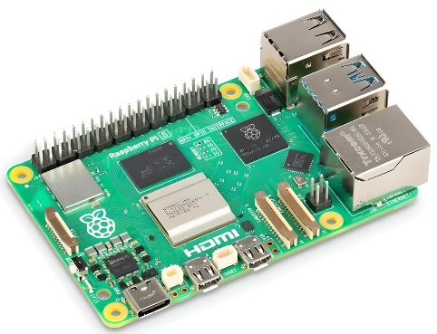
Figure ‎4-1: Raspberry Pi 5

Table ‎4-1: Raspberry Pi 5 Specifications

Description
The Raspberry Pi 5 is a high-performance single-board computer designed for embedded and real-time applications. At its core, it features a 2.4 GHz Quad-Core ARM Cortex-A76 processor and 8 GB LPDDR4X RAM, enabling it to process complex computational tasks efficiently while maintaining low power consumption. Its VideoCore VII GPU supports hardware-accelerated graphics and video processing, allowing it to handle real-time image and video analysis, which is critical in autonomous or semi-autonomous vehicles.
Connectivity is one of the Raspberry Pi 5’s key strengths. It supports dual 4K displays through micro-HDMI ports, high-speed data transfer via USB 3.0 and Gigabit Ethernet, and wireless communication through Wi-Fi 802.11ac and Bluetooth 5.0. This combination of wired and wireless interfaces ensures reliable data exchange between sensors, controllers, and external networks. The dual MIPI CSI camera connectors enable integration of multiple cameras for vision-based applications, such as object detection, lane detection, and environmental mapping.
The board includes a 40-pin GPIO header, fully backward compatible, which allows seamless integration with additional microcontrollers, sensors, and actuators. This makes it ideal for modular system design, where different hardware components must communicate and work in sync. Its microSD card slot supports storage expansion up to 1 TB, allowing the system to handle large datasets generated by sensors and cameras during operation. The USB-C power input ensures stable operation even when performing high-demand tasks, reducing the risk of system interruptions.
Physically, the Raspberry Pi 5 is compact (85 × 56 mm), making it suitable for embedded applications in vehicles with limited space. It combines processing power, versatility, and modularity, allowing it to act as the central hub of complex intelligent systems. In addition, the board is capable of interfacing with real-time clock modules, external storage devices, and additional expansion boards, which is crucial for applications requiring time-sensitive control and data logging.
Overall, the Raspberry Pi 5 provides the necessary performance, flexibility, and reliability for implementing advanced SDV applications, making it a core component for smart vehicle operations, real-time environmental monitoring, and intelligent decision-making processes. Its ability to coordinate multiple sensors, cameras, and controllers ensures that the SDV system operates efficiently and safely within a smart city environment.

Usage
In the Modular Smart Transportation System, the Raspberry Pi 5 serves as the main processing and control hub. Its primary role is to manage communication between all hardware modules and ensure smooth real-time operation of the vehicle.
The Raspberry Pi 5 collects sensor data from the IMU 9DoF, ultrasonic sensors, and GPS module, processes it, and generates control signals for actuators connected to the ATmega32A and other microcontrollers. It also handles video input from the Raspberry Pi Camera v2 and Xbox 360 Kinect Camera, performing real-time image processing for tasks such as object detection, lane monitoring, and environmental mapping.
Through its GPIO pins, the Raspberry Pi interfaces with microcontrollers and expansion boards, sending commands and receiving feedback from sensors and peripheral devices. Its wireless communication modules (Wi-Fi and Bluetooth) allow remote monitoring, system updates, and integration with external smart city networks, while Gigabit Ethernet ensures high-speed data transfer when wired connections are needed.
Additionally, the Raspberry Pi 5 coordinates the display output to the LCD 20x4 with I2C, showing system status, sensor readings, and diagnostic information during testing and operation. Its high processing capability ensures that multiple sensors and cameras can be managed simultaneously without delay, making it the central hardware unit that maintains the SDV’s performance, reliability, and responsiveness.
In summary, the Raspberry Pi 5’s usage in the system is as the brain of the SDV, integrating all sensory inputs, processing information in real-time, controlling actuators, and ensuring communication between modules, while providing flexibility for future system expansions.

ATmega32A

Specifications
Feature | Specification
Microcontroller | ATmega32A (AVR 8-bit)
Operating Voltage | 5V
Flash Memory | 32 KB
SRAM | 2 KB
EEPROM | 1 KB
Clock Speed | 16 MHz
GPIO Pins | 32 (including ADC channels)
Communication Interfaces | UART, SPI, I2C
ADC | 8 channels, 10-bit resolution
PWM Channels | 8
Package | 40-pin DIP / TQFP
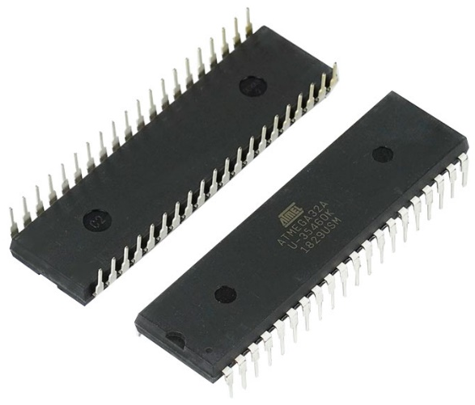
Table ‎4-2: ATmega32A Specifications
Figure ‎4-2: ATmega32A

Description
The ATmega32A is an 8-bit microcontroller from the AVR family, widely used in embedded systems for applications requiring low to medium computational power. Operating at 5V with a 16 MHz clock, it combines high efficiency and reliability in a compact package. The 32 KB flash memory stores programs and firmware, while 2 KB SRAM allows temporary data handling during operation. Its 32 general-purpose I/O pins provide versatile interfacing with a wide range of sensors, actuators, and external modules.
The microcontroller supports multiple communication protocols, including UART, SPI, and I2C, allowing easy integration with devices such as the ESP32, displays, motor drivers, and various sensors. Its 8 ADC channels with 10-bit resolution enable accurate analog-to-digital conversions for sensors measuring distance, acceleration, and orientation. Additionally, 8 PWM channels facilitate precise control of motors, servos, and other actuators, which is crucial for implementing motion control in vehicles.
The ATmega32A is optimized for real-time operations. Its internal timers and counters allow it to perform tasks such as pulse measurement, event timing, and waveform generation with high precision. It also supports external interrupts, enabling rapid response to critical events, such as obstacle detection or emergency signals from sensors.
Physically, the ATmega32A comes in 40-pin DIP or TQFP packages, allowing easy integration into breadboards, PCBs, or modular embedded setups. Its low power consumption and robust design make it suitable for continuous operation in vehicles, even under varying environmental conditions. Furthermore, it can serve as a dedicated co-processor alongside higher-level units like the Raspberry Pi 5, handling time-critical control and interfacing tasks while freeing the main processor for heavy computation and AI-based operations.
Overall, the ATmega32A’s combination of flexible I/O, real-time processing, communication versatility, and low power requirements makes it an essential component in the SDV system. It provides reliable control and interfacing for the vehicle’s sensors and actuators, supporting modularity, scalability, and efficient hardware coordination in the smart transportation framework.

Usage
In the Modular Smart Transportation System, the ATmega32A functions as a dedicated local control unit, responsible for managing time-critical and low-level operations. It handles tasks that require precise timing and rapid response, such as reading data from ultrasonic sensors, interpreting signals from IMU 9DoF modules, and generating PWM signals to control motors, servos, and other actuators. By executing these tasks locally, the ATmega32A ensures that real-time control loops operate reliably without delays caused by higher-level processing on the Raspberry Pi 5.
The microcontroller interfaces with the Raspberry Pi 5 and ESP32 through UART, SPI, and I2C communication protocols, allowing it to send processed sensor data and receive commands for vehicle operation. Its ADC channels convert analog signals from sensors into digital values, enabling accurate measurement of distances, orientations, and environmental parameters. Simultaneously, its PWM channels precisely control the speed, position, and direction of motors and actuators, supporting smooth vehicle motion and stable responses to dynamic environments.
Additionally, the ATmega32A manages interrupt-driven tasks, such as emergency braking signals, obstacle detection alerts, and sensor fault monitoring. This ensures that the system can respond immediately to critical situations, enhancing the safety and reliability of the SDV. By offloading time-sensitive operations from the Raspberry Pi 5, it allows the main processor to focus on high-level computation, such as AI-based perception, path planning, and decision-making.
The ATmega32A also plays a key role in modular hardware integration. It coordinates multiple sensor inputs and actuator outputs simultaneously, ensuring seamless interaction between components such as ultrasonic sensors, IMU, motors, and LCD displays. This modular control approach enables scalability, as additional sensors or actuators can be integrated into the system without compromising real-time responsiveness.
Overall, the ATmega32A serves as the real-time backbone of the SDV’s control system. Its combination of fast local processing, flexible interfacing, and reliable timing ensures that the vehicle responds accurately and efficiently to both sensor inputs and high-level commands, maintaining smooth operation and enhancing the overall performance, safety, and modularity of the smart transportation system.

IMU Sensor (MPU9250)

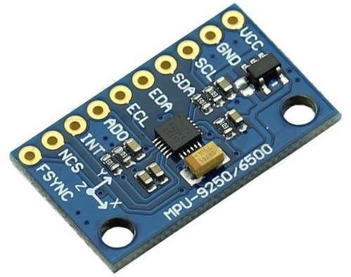
Specifications
Figure ‎4-3: MPU9250
Feature | Specification
Sensor Type | 9 Degrees of Freedom (3-axis gyro, 3-axis accelerometer, 3-axis magnetometer)
Gyroscope Range | ±250, ±500, ±1000, ±2000 °/s
Accelerometer Range | ±2g, ±4g, ±8g, ±16g
Magnetometer Range | ±4800 µT
Communication Interface | I2C / SPI
Operating Voltage | 3.3V
Power Consumption | 3.5 mA (typical)
Dimensions | 3 × 3 × 0.9 mm
Temperature Range | -40°C to +85°C
Table ‎4-3: MPU9250 Specifications

Description
The MPU-9250 is a compact, high-performance 9DoF (Degrees of Freedom) Inertial Measurement Unit (IMU) that integrates a 3-axis gyroscope, 3-axis accelerometer, and 3-axis magnetometer into a single, lightweight package. It is designed for embedded systems and real-time applications that require accurate motion sensing, orientation tracking, and spatial awareness, making it ideal for smart transportation systems.
The gyroscope provides precise angular velocity measurements, allowing the system to detect rotation around all three axes (pitch, roll, and yaw). The accelerometer measures linear acceleration, which is essential for understanding vehicle movement, detecting sudden starts or stops, and assisting in inertial navigation. The magnetometer measures the Earth’s magnetic field, providing absolute heading information that complements gyroscope and accelerometer readings to improve orientation accuracy.
The MPU-9250 communicates via I2C or SPI interfaces, offering fast, reliable, and low-latency integration with controllers such as ESP32 or ATmega32A. It operates at 3.3V and consumes very low power, allowing continuous operation without significantly affecting the energy budget of the SDV. Its small form factor (3 × 3 × 0.9 mm) enables easy placement within the vehicle’s compact hardware architecture.
Internally, the MPU-9250 features DMP, which can perform pre-processing of sensor data on-board. This allows partial computation of orientation and motion parameters to be handled by the sensor itself, reducing the computational load on the main processor, such as the Raspberry Pi 5, and increasing the efficiency and responsiveness of the system.
The sensor also includes configurable filters, sensitivity settings, and calibration options, which allow precise tuning for different vehicle dynamics and environmental conditions. This ensures that readings remain accurate even under vibration, shocks, or rapid maneuvers.
In addition, the MPU-9250 supports fusion of gyroscope, accelerometer, and magnetometer data, providing a stable and reliable orientation estimate that is essential for autonomous navigation, lane keeping, obstacle avoidance, and stabilization algorithms. Its integration ensures that the SDV can maintain accurate awareness of its position and orientation in real time, improving safety and performance in complex and dynamic urban environments.
Overall, the MPU-9250 combines high precision, low power consumption, real-time processing capabilities, and flexible interfacing, making it a critical component in the smart vehicle’s sensor suite. Its ability to continuously track motion and orientation ensures smooth and reliable operation of the SDV, supporting both autonomous and semi-autonomous functions.

Usage
In the Modular Smart Transportation System, the MPU-9250 IMU serves as a primary source of motion and orientation data, providing continuous real-time measurements of pitch, roll, yaw, acceleration, and angular velocity. This information is critical for maintaining vehicle stability, supporting lane tracking, detecting sudden maneuvers, and enabling smooth navigation in dynamic urban environments.
The IMU interfaces with the ESP32 and Raspberry Pi 5 through I2C or SPI communication, sending processed motion data to higher-level control units. The Raspberry Pi 5 leverages this data for navigation algorithms, object avoidance strategies, and real-time vehicle control, while the ESP32 uses it for low-level stabilization and feedback loops. The IMU’s readings are fused with GPS, ultrasonic sensors, and wheel encoder data to enhance positional accuracy and correct potential errors caused by sensor drift or magnetic interference.
Additionally, the MPU-9250 supports onboard Digital Motion Processing (DMP), which calculates orientation estimates internally. This offloads some computational demand from the Raspberry Pi 5, ensuring faster response times and minimizing latency in motion detection and control. The IMU is also used in sensor calibration routines, aligning and synchronizing multiple sensors to maintain consistent and reliable data across the system.
The MPU-9250’s high sampling rate and precision allow it to detect subtle changes in vehicle motion, enabling advanced functions such as adaptive stabilization, trajectory prediction, and automated safety responses in sudden maneuvers. By continuously providing accurate orientation and motion data, it ensures that the SDV can dynamically adjust its behavior, enhancing ride safety, system reliability, and overall vehicle performance.
Moreover, its compact size and low power consumption allow integration into the vehicle’s modular hardware without affecting space or energy budgets. The IMU acts as a core sensory unit, enabling the SDV to maintain awareness of its physical state at all times, respond to environmental changes effectively, and support autonomous or semi-autonomous driving operations in a smart city context.

Ultrasonic Sensor

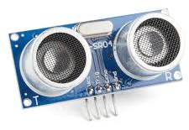
Specifications
Figure ‎4-4: Ultrasonic Sensor
Feature | Specification
Sensor Type | Ultrasonic Distance Sensor
Operating Voltage | 5V
Measurement Range | 2 cm – 400 cm
Accuracy | ±3 mm
Operating Frequency | 40 kHz
Detection Angle | ~15°
Interface | Digital (Trigger/Echo)
Response Time | 100 ms
Dimensions | 45 × 20 × 15 mm
Table ‎4-4: Ultrasonic Specifications

Description
The Ultrasonic Sensor is a precise, non-contact distance measuring device that operates using high-frequency sound waves, typically at 40 kHz, to detect objects and calculate their distance. It consists of a transmitter that emits ultrasonic pulses and a receiver that measures the time taken for the pulses to reflect back from nearby objects. This time-of-flight measurement is then converted into distance using the speed of sound.
The sensor operates at 5V and can measure distances ranging from 2 cm to 4 meters with a high accuracy of ±3 mm. Its narrow detection angle (~15°) allows it to focus on objects directly in front of the sensor, reducing interference from surrounding objects and enhancing measurement precision. The fast response time (~100 ms) ensures near real-time detection, which is crucial for obstacle avoidance and collision prevention in dynamic environments.
Internally, the sensor includes signal conditioning circuitry that filters noise and stabilizes the output, providing reliable readings even in challenging conditions such as vibrations, uneven surfaces, or slight misalignments. The digital Trigger and Echo interface makes it easy to integrate with microcontrollers like ATmega32A or ESP32, simplifying data acquisition and reducing the need for complex analog circuitry.
Ultrasonic sensors are lightweight, compact, and energy-efficient, making them ideal for embedding into vehicles where space and power are limited. They can be deployed in arrays to cover multiple directions, enabling 360-degree environmental awareness. When combined with other sensors, such as IMU 9DoF, GPS, or cameras, the ultrasonic sensor contributes to a robust multi-sensor system capable of providing reliable situational awareness for autonomous or semi-autonomous driving.
Additionally, the sensor’s ability to detect sudden changes in distance allows it to support safety-critical functions, such as emergency braking, adaptive speed control, and obstacle-triggered alerts. Its integration into a modular system ensures that each sensor module can operate independently while providing accurate data to the central processing unit, such as the Raspberry Pi 5, for high-level decision-making.
Overall, the ultrasonic sensor is a critical component for environmental perception, offering precise, real-time object detection, flexible integration, and reliable performance, enhancing the SDV’s safety, responsiveness, and overall navigation capabilities in smart transportation applications.

Usage
In the Modular Smart Transportation System, ultrasonic sensors serve as a primary tool for obstacle detection, proximity monitoring, and situational awareness. They provide continuous real-time measurements of distances to objects around the vehicle, which are critical for collision avoidance, lane keeping, low-speed maneuvering, and safe navigation in urban environments.
The sensors are connected to the ATmega32A microcontroller, which processes the Trigger and Echo signals to calculate precise distances. This processed data is then transmitted to the Raspberry Pi 5 and ESP32, where it is integrated with information from other sensors, such as the MPU-9250 IMU, GPS, and cameras. This sensor fusion ensures the vehicle has a reliable understanding of its environment, compensating for potential inaccuracies or blind spots from individual sensors.
Ultrasonic sensors are strategically positioned around the vehicle to provide 360-degree coverage, detecting obstacles from all directions. This configuration supports advanced features such as multi-point collision detection, adaptive speed control, and dynamic path adjustment, allowing the SDV to respond accurately to sudden obstacles, pedestrians, or other vehicles. Their high-frequency operation (~40 kHz) and rapid response time (~100 ms) enable near real-time monitoring, which is essential for fast decision-making in complex traffic situations.
The integration of ultrasonic sensors also contributes to redundancy and safety, as multiple sensors provide overlapping detection zones. This redundancy ensures that the system can continue operating reliably even if one sensor is blocked or temporarily fails. Data from the sensors is used in combination with control algorithms on the Raspberry Pi 5 and ESP32 to dynamically adjust motor outputs, steering, and braking, ensuring smooth and safe vehicle motion.
Furthermore, the sensors are essential for supporting autonomous and semi-autonomous behaviors, such as automated parking, obstacle-triggered alerts, and low-speed navigation in confined spaces. By continuously monitoring the vehicle’s surroundings and providing timely feedback to the control units, ultrasonic sensors enhance the SDV’s accuracy, safety, and operational reliability, making them a critical component in the vehicle’s modular hardware ecosystem.

LCD 20x4

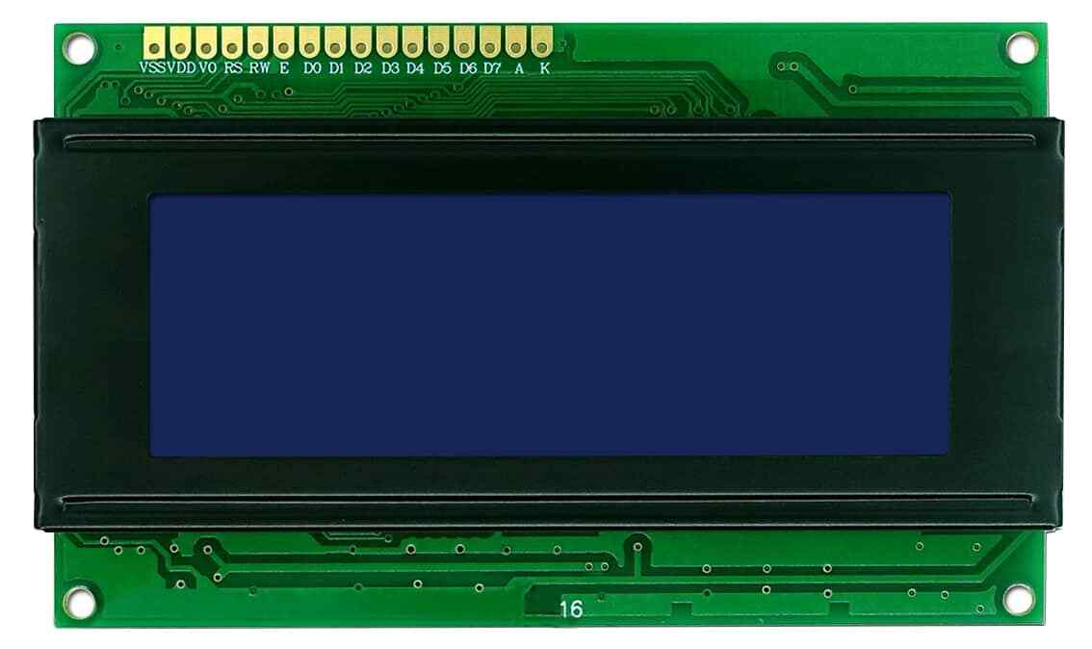
Specifications
Figure ‎4-5: LCD 20x4
Feature | Specification
Display Type | Character LCD
Characters | 20 characters per line × 4 lines
Interface | Parallel (standard 16-pin)
Operating Voltage | 5V
Backlight | LED backlight
Viewing Angle | 6 o’clock optimal
Operating Temperature | 0°C – 50°C
Dimensions | 98 × 60 × 12 mm
Controller | HD44780 compatible
Table ‎4-5: LCD Specifications

Description
The LCD 20×4 is a character-based liquid crystal display capable of presenting 20 characters per line across 4 lines, providing a versatile and compact solution for displaying system status, sensor readings, and debugging information. Its 5V operation voltage and built-in LED backlight allow clear visibility under various lighting conditions, including low-light or shaded environments, making it suitable for in-vehicle or embedded applications.
The display is driven by an HD44780-compatible controller, which offers a standardized and reliable interface for sending text, commands, and simple custom characters to the screen. The LCD can be interfaced through a 16-pin parallel connection, providing straightforward communication with microcontrollers like ATmega32A, ESP32, or other embedded platforms. For more advanced or space-constrained applications, it can be paired with an I2C adapter, reducing pin usage to just SDA and SCL, simplifying wiring and allowing integration into complex modular systems without consuming excessive GPIO resources.
Its compact and lightweight design ensures that it fits seamlessly into embedded hardware setups, while its low power consumption allows continuous operation without significant load on the system’s energy budget. The display is also durable and robust, capable of functioning reliably under the vibrations and temperature variations typical of vehicle environments.
The LCD’s wide viewing angle ensures that information is legible from multiple positions, and the adjustable backlight provides enhanced readability in varying ambient conditions. This makes it an effective tool not only for system monitoring but also for providing user feedback in real-time, such as alerts for sensor readings, operational status, or warnings about potential obstacles.
In smart transportation applications, the LCD acts as a human-readable interface that bridges the gap between the vehicle’s embedded hardware and the operator or developer. It allows quick visual verification of sensor data, system modes, and operational performance during testing, calibration, or live operation. By providing clear and structured information, the LCD contributes to safe, reliable, and efficient system management, making it an essential component in the SDV’s modular architecture.

Usage
In the Modular Smart Transportation System, the LCD 20×4 serves as a primary human-readable interface, providing operators and developers with real-time feedback about the vehicle’s operational status. It displays critical information such as sensor readings (ultrasonic distances, IMU orientation, GPS coordinates), system alerts, operational modes, and debugging messages, enabling immediate awareness of the SDV’s performance and environment.
The LCD is directly connected to the ATmega32A or other microcontrollers via the standard parallel interface, allowing fast and reliable data communication. For more efficient wiring and reduced GPIO usage, it is often paired with an I2C module, which simplifies the connection to just two wires (SDA and SCL). This setup not only conserves microcontroller pins but also facilitates integration into more complex modular architectures, where multiple devices share the same communication bus.
During operation, the microcontroller continuously formats and sends data to the LCD, ensuring that operators can monitor real-time changes in sensor readings, detect anomalies, and observe the vehicle’s immediate responses to environmental inputs. This is particularly valuable during system testing, calibration, and troubleshooting, as it provides instant visual confirmation of the functionality of sensors, actuators, and microcontroller logic without requiring external debugging tools.
The LCD also enhances system transparency and modularity. By visually displaying sensor and control data, it allows multiple team members or operators to understand the vehicle’s status simultaneously. It can be used to display alerts for critical events, such as obstacle proximity, GPS errors, or abnormal sensor behavior, improving the SDV’s safety and reliability.
Moreover, the LCD supports multi-line, multi-character formatting, allowing complex information to be displayed clearly, including operational summaries, mode indicators, and live sensor statistics. This makes it an invaluable tool for monitoring the performance of integrated subsystems like the ultrasonic sensors, IMU, GPS module, and motor controllers, ensuring that the SDV operates safely and efficiently under dynamic driving conditions.
By providing continuous, readable, and organized feedback, the LCD 20×4 contributes to effective system management, faster debugging, safer operation, and smoother integration of modular hardware components, making it a critical component in the smart transportation framework.

GPS (Ublox NEO-6M)

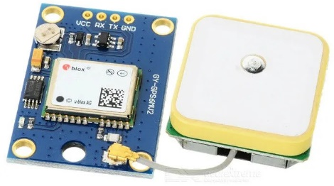
Specifications
Figure ‎4-6: Ublox NEO-6m GPS Module
Feature | Specification
Operating Voltage | 3.3V – 5V
Frequency | 1 Hz – 5 Hz update rate
Accuracy | Horizontal: ±2.5 m, Vertical: ±5 m
Channels | 22 tracking channels
Communication Interface | UART
Antenna | Built-in ceramic patch or external SMA connector
Dimensions | 25 × 25 × 4 mm
Power Consumption | ~45 mA
Operating Temperature | -40°C to +85°C
Table ‎4-6: Ublox NEO-6m GPS Module Specifications

Description
The Ublox NEO-6M GPS module is a compact, high-precision satellite navigation receiver designed to track a vehicle’s geographic position, velocity, and time in real time. Operating within a voltage range of 3.3V to 5V, it communicates via UART, making it highly compatible with microcontrollers such as ATmega32A, ESP32, or higher-level computing platforms like the Raspberry Pi 5. This simplicity of integration allows the module to be quickly incorporated into embedded systems without complex circuitry or programming.
The module features 22 tracking channels, enabling it to simultaneously communicate with multiple GPS satellites. This multi-channel capability ensures robust signal acquisition, fast satellite lock times, and stable position data, even in environments with partial signal obstruction, such as urban canyons or areas with dense foliage. The module provides horizontal positioning accuracy up to ±2.5 meters and vertical accuracy up to ±5 meters, with an update rate between 1 Hz and 5 Hz, allowing continuous real-time tracking suitable for dynamic vehicle applications.
The built-in ceramic patch antenna ensures compactness and reliable signal reception, while the option to use an external SMA antenna provides flexibility for enhanced signal strength in challenging environments. The GPS module’s low power consumption (~45 mA) and lightweight form factor make it ideal for embedded systems where energy efficiency and size constraints are critical. Additionally, it is designed to operate across a wide temperature range (-40°C to +85°C), ensuring robust performance under extreme environmental conditions, from hot asphalt surfaces to cold outdoor deployments.
The NEO-6M provides not only geographic coordinates and speed but also precise time synchronization, which is essential for coordinating sensors, logging events, and enabling communication protocols such as V2V (Vehicle-to-Vehicle) or V2X (Vehicle-to-Everything). When integrated with other sensors, such as the IMU 9DoF, ultrasonic sensors, and cameras, the GPS module plays a critical role in sensor fusion, enhancing overall vehicle localization, trajectory estimation, and navigation accuracy.
Its reliability, ease of integration, and ability to deliver continuous, high-precision data make the NEO-6M GPS module an indispensable component for autonomous and semi-autonomous vehicle systems. It enables the SDV to perform real-time route tracking, adaptive navigation, and coordinated control of actuators, ensuring safe and efficient operation in dynamic urban and highway environments.
Overall, the Ublox NEO-6M GPS module combines accuracy, robustness, low power, and integration flexibility, providing a critical foundation for spatial awareness, navigation, and intelligent decision-making within the Modular Smart Transportation System.

Usage
In the Modular Smart Transportation System, the Ublox NEO-6M GPS module provides continuous real-time geographic position, velocity, and timing data, which forms a cornerstone for the vehicle’s navigation and situational awareness. GPS readings are transmitted via UART to the ESP32 or Raspberry Pi 5, where they are processed alongside other sensor inputs to form a comprehensive understanding of the vehicle’s environment and motion.
The GPS module plays a critical role in vehicle localization, allowing the system to determine the SDV’s precise position within a road network or mapped environment. This positional data is used for route planning, trajectory prediction, and dynamic path adjustment, enabling higher-level algorithms to make informed navigation decisions. When combined with IMU 9DoF data, the system can implement sensor fusion techniques that enhance positioning accuracy in challenging environments, such as urban canyons, tunnels, or areas with intermittent satellite visibility.
GPS data also supports real-time speed monitoring and travel logging, providing essential information for both operational performance and data analysis. By correlating GPS-based velocity measurements with IMU acceleration and motor feedback, the SDV can accurately calculate motion parameters, detect deviations, and adjust control commands for smoother and safer operation.
The module’s precise timing capability is particularly valuable for coordinating multiple vehicle modules, synchronizing sensor readings, and supporting V2V (Vehicle-to-Vehicle) or V2X (Vehicle-to-Everything) communications. Accurate timestamps ensure that data from distributed sensors can be reliably aligned for multi-sensor fusion, obstacle detection, and coordinated autonomous decision-making.
In multi-sensor configurations, the GPS module contributes to redundancy and reliability, allowing the SDV to maintain accurate navigation even if other sensors experience temporary failure or degraded performance. Its integration into the SDV system enhances operational safety, ensuring that the vehicle can maintain situational awareness, make timely decisions, and react appropriately to dynamic road conditions.
Moreover, the GPS module aids in autonomous or semi-autonomous behaviors, such as route following, geofencing, and adaptive speed control. By providing consistent and accurate spatial information, it enables the vehicle to navigate complex urban environments, coordinate with other vehicles, and optimize energy-efficient travel paths.
Overall, the Ublox NEO-6M GPS module is a critical enabler of intelligent navigation and geospatial awareness in the Modular Smart Transportation System. Its real-time positional, velocity, and timing data enhance sensor fusion, control algorithms, and decision-making processes, ensuring that the SDV operates safely, efficiently, and reliably in both routine and dynamic driving scenarios.

ESP32

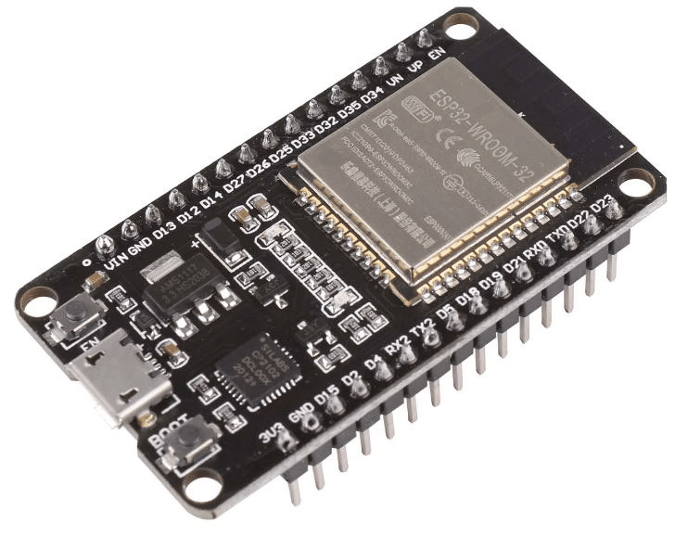
Specifications
Figure ‎4-7: ESP32
Feature | Specification
Microcontroller | ESP32 (Tensilica Xtensa Dual-Core)
Operating Voltage | 3.3V
Clock Speed | Up to 240 MHz
RAM | 520 KB SRAM
Flash Memory | 4 MB – 16 MB (depending on module)
Wi-Fi | 802.11 b/g/n
Bluetooth | v4.2 BR/EDR & BLE
GPIO Pins | 34 configurable pins
ADC Channels | 12-bit, up to 18 channels
DAC Channels | 2 channels, 8-bit
Communication Interfaces | UART, SPI, I2C, PWM, CAN
Operating Temperature | -40°C to +125°C
Power Consumption | ~80 mA (typical)
Table ‎4-7: ESP32 Specifications

Description
The ESP32 is a highly versatile, low-power system-on-chip microcontroller designed for embedded and IoT applications, particularly where wireless communication is essential. It integrates a dual-core Tensilica Xtensa LX6 processor capable of running up to 240 MHz, providing sufficient computational power to manage complex communication protocols, data handling, and peripheral management. Alongside its 520 KB internal SRAM, the ESP32 can leverage external flash memory (4–16 MB) for program storage, enabling scalable applications and firmware updates in embedded systems.
The ESP32 features 34 configurable GPIO pins, allowing it to interface with a broad range of digital and analog devices. It supports multiple communication protocols, including UART, SPI, I2C, PWM, and CAN, which enables seamless integration with other microcontrollers, vehicle modules, and peripheral systems. The device also includes 12-bit ADC channels for analog data acquisition and 8-bit DAC channels for analog signal generation, though in the SDV system these are secondary to its communication functionality.
Designed for low-power operation, the ESP32 supports several energy-saving modes, including sleep and deep sleep, making it suitable for battery-powered systems or modules that require intermittent operation while maintaining network connectivity. Its integrated Wi-Fi (802.11 b/g/n) and Bluetooth v4.2 (BR/EDR & BLE) provide versatile, real-time wireless communication options, enabling the microcontroller to handle Vehicle-to-Vehicle (V2V), Vehicle-to-Infrastructure (V2I), and Vehicle-to-Everything (V2X) communications efficiently.
In addition to its wireless capabilities, the ESP32 offers robust hardware architecture, including hardware encryption, support for multiple communication stacks, and reliable timing for message handling. This ensures low-latency data exchange between vehicles, smart infrastructure, and central servers, which is critical for cooperative driving, traffic coordination, collision warnings, and autonomous system integration.
In the Modular Smart Transportation System, the ESP32 is not used for direct sensor interfacing or computation but serves as a dedicated communication module. Its wireless capabilities allow the SDV to transmit and receive data from other vehicles and smart infrastructure in real time, supporting connected vehicle functionalities. By isolating communication tasks on the ESP32, the system ensures that critical vehicle control and perception processes on the Raspberry Pi 5 and ATmega32A remain uninterrupted, while maintaining reliable and low-latency network connections.
Overall, the ESP32 is a key enabler of connectivity, modularity, and scalability within the smart transportation system. Its combination of powerful processing, extensive I/O flexibility, and integrated Wi-Fi/Bluetooth makes it an indispensable component for integrating the SDV into a broader connected and intelligent transportation network, enhancing both safety and operational efficiency.

Usage
In the Modular Smart Transportation System, the ESP32 serves as the dedicated communication backbone, enabling the SDV to actively participate in a fully connected transportation network. Its primary function is to manage V2V (Vehicle-to-Vehicle), V2I (Vehicle-to-Infrastructure), and V2X (Vehicle-to-Everything) communications, allowing seamless data exchange between the vehicle, other vehicles, roadside infrastructure, and central traffic management systems.
Using its integrated Wi-Fi and Bluetooth modules, the ESP32 transmits and receives real-time information, including vehicle status, location coordinates, sensor summaries, operational alerts, and control commands. This ensures that the SDV is continuously aware of its environment, neighboring vehicles, traffic signals, and potential hazards, allowing for cooperative driving, dynamic routing, and collision avoidance.
By offloading all wireless communication tasks from the main processor (Raspberry Pi 5), the ESP32 ensures that critical real-time control, sensor processing, and perception algorithms remain uninterrupted, maintaining the performance and safety of the vehicle’s operational systems. Its low-latency networking capabilities guarantee that messages between vehicles or infrastructure are delivered promptly, supporting time-sensitive decisions in dynamic driving environments.
The ESP32 also enhances the modularity and scalability of the SDV platform. Multiple ESP32 modules can be deployed in a single vehicle or across a fleet to manage different communication channels, network priorities, or protocol layers without overloading the main processor. This modular approach allows the SDV system to expand its communication capabilities as new standards, sensors, or V2X technologies are integrated.
In addition, the ESP32 supports secure communication through hardware encryption and software protocols, protecting the vehicle’s data from unauthorized access or tampering. This is critical in connected transportation systems where sensitive information, such as location or control commands, must remain confidential to ensure passenger safety and system reliability.
Overall, the ESP32 provides a robust, reliable, and intelligent communication layer, forming the foundation for the SDV’s integration into smart city networks. Its role ensures that the vehicle can participate in cooperative traffic management, connected fleet operations, and autonomous decision-making, while maintaining network awareness, safety, and operational efficiency.

Raspberry Pi Camera v2

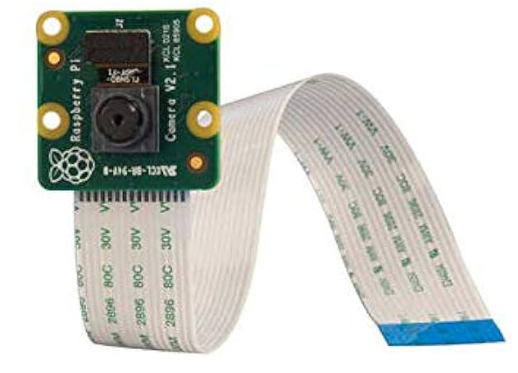
Specifications
Figure ‎4-8: Raspberry Pi Camera v2
Feature | Specification
Sensor | Sony IMX219 8-megapixel
Resolution | 3280 × 2464 pixels (still images), 1080p at 30 fps (video)
Lens | Fixed focus, 3.6 mm focal length
Field of View | ~62°
Interface | CSI-2 (Camera Serial Interface)
Shutter | Rolling shutter
Max Frame Rate | 1080p at 30 fps, 720p at 60 fps, VGA at 90 fps
Power Supply | 3.3V – 5V
Dimensions | 25 × 23 × 9 mm
Operating Temperature | 0°C to +50°C
Table ‎4-8: Raspberry Pi Camera v2 Specifications

Description
The Raspberry Pi Camera v2 is a high-resolution, compact camera module specifically designed for embedded systems and real-time computer vision applications. It interfaces directly with Raspberry Pi boards via the CSI-2 interface, which allows high-speed, low-latency transfer of image and video data for continuous processing. The camera uses the Sony IMX219 sensor, capable of capturing 8-megapixel still images and recording 1080p full HD video at 30 fps, while supporting lower resolutions at higher frame rates (720p at 60 fps, VGA at 90 fps) for faster motion analysis.
The module features a fixed-focus lens with a 3.6 mm focal length and a 62° field of view, optimized for capturing detailed scenes in front of the vehicle or monitoring the interior environment. Its compact dimensions (25 × 23 × 9 mm) and low power consumption (3.3V–5V) make it highly suitable for integration in autonomous vehicles, ADAS modules, or embedded monitoring systems where space and energy efficiency are critical. The camera operates reliably under typical indoor and outdoor conditions within its rated temperature range, ensuring consistent performance across diverse environments.
Designed for embedded perception tasks, the Raspberry Pi Camera v2 supports a variety of computer vision applications, including lane detection, object recognition, traffic sign detection, motion tracking, and driver monitoring. It can deliver continuous video streams to the Raspberry Pi 5, enabling real-time processing for both vehicle navigation systems and driver safety monitoring. The camera’s high resolution and frame rate allow it to detect subtle movements, facial expressions, and gestures, which are essential for Driver Monitoring Systems (DMS) in ADAS, such as identifying fatigue, distraction, or inattentiveness.
Additionally, the camera module can be combined with other SDV sensors—such as the IMU 9DoF, ultrasonic sensors, and GPS—to enhance sensor fusion capabilities. This integration enables the vehicle to correlate visual input with motion, distance, and location data, improving situational awareness, navigation accuracy, and autonomous decision-making.
The Raspberry Pi Camera v2 also supports advanced image processing techniques, such as real-time image filtering, object tracking, and feature extraction, which are critical for robust ADAS functionality. Its integration with machine learning or deep learning frameworks allows the SDV to implement predictive analysis, hazard detection, and adaptive responses, making it an indispensable component for smart transportation systems.
Overall, the Raspberry Pi Camera v2 combines high-resolution imaging, real-time performance, compact design, and low power consumption, providing a reliable and flexible perception module for both autonomous vehicle navigation and driver monitoring applications. Its role ensures that the SDV maintains a safe, intelligent, and responsive operational environment.

Usage
In the Modular Smart Transportation System, the Raspberry Pi Camera v2 serves as a critical Driver Monitoring Camera (DMC) within the ADAS framework, continuously assessing the driver’s state to improve safety and prevent accidents. Its primary function is to detect fatigue, distraction, drowsiness, or inattentiveness, providing timely feedback to the driver and supporting automated safety interventions.
The camera connects directly to the Raspberry Pi 5 via the CSI-2 interface, which enables high-speed, low-latency video streaming for real-time processing. Advanced computer vision algorithms running on the Raspberry Pi analyze facial landmarks, eye closure, gaze direction, head pose, and facial expressions to evaluate the driver’s alertness. These metrics are continuously monitored to detect early signs of fatigue or distraction.
By integrating the driver monitoring camera with other ADAS components, such as the ultrasonic sensors, IMU 9DoF, and GPS, the system can correlate driver behavior with vehicle dynamics and environmental conditions. For example, sudden lane deviations or rapid braking can be cross-referenced with detected driver fatigue to trigger alerts or assistive interventions. This sensor fusion approach enhances both the accuracy of detection and the reliability of safety measures.
The Raspberry Pi Camera v2 enables the SDV to issue real-time alerts, such as visual or audible warnings, or engage automated safety responses when necessary. It also supports data logging, allowing the system to store driver behavior patterns for analysis, improvement of machine learning models, or integration into fleet safety management.
Designed for continuous monitoring under varying lighting conditions inside the vehicle, the camera ensures consistent performance, using adaptive exposure and frame rate adjustments to maintain reliable detection even at night or under strong sunlight. Its high resolution and rapid frame capture allow detection of subtle cues, ensuring that even micro-expressions and brief lapses in attention are detected promptly.
Furthermore, the Raspberry Pi Camera v2 enhances human-machine interaction by enabling context-aware ADAS features, such as adaptive cruise control, intelligent lane keeping, or alert prioritization based on driver state. Its real-time monitoring ensures that the vehicle can adapt its behavior dynamically, maintaining optimal safety without compromising driving comfort or responsiveness.
Overall, the Raspberry Pi Camera v2 provides a comprehensive perception layer for driver safety, supporting advanced monitoring, predictive alerts, and integration with the full ADAS ecosystem. It plays a pivotal role in ensuring the SDV operates safely, intelligently, and responsively in a variety of driving conditions, making it a cornerstone of the smart transportation system’s human-centered design.

Xbox 360 Kinect Camera


Specifications
Figure ‎4-9: Xbox 360 Kinect Camera
Feature | Specification
Sensor Type | RGB Camera + Depth Sensor
Resolution | RGB: 640×480 (VGA) up to 1280×960 (still images), Depth: 320×240
Frame Rate | RGB: 30 fps, Depth: 30 fps
Field of View | RGB: 57°, Depth: 43°
Depth Range | 0.8 m – 4 m
Interface | USB 2.0
Power Supply | 12V external adapter
Operating Temperature | 0°C to 40°C
Dimensions | 270 × 30 × 70 mm (sensor bar)
Table ‎4-9: Xbox 360 Kinect Camera Specifications

Description
The Xbox 360 Kinect Camera is a versatile motion-sensing input device that combines an RGB camera with an infrared depth sensor and has been widely adopted beyond gaming for robotics, human-machine interaction, computer vision, and smart vehicle applications. By providing both color images and depth maps, the Kinect enables real-time 3D spatial perception, making it a powerful tool for monitoring both the interior and exterior of vehicles.
The RGB camera captures still images at resolutions up to 1280×960 and video streams at 640×480, while the depth sensor measures distances ranging from 0.8 m to 4 m with high precision. This allows the system to accurately map environments in three dimensions, distinguish objects, and detect human presence and movement within the cabin. The depth sensor relies on an infrared projector and receiver, which enables operation in low-light or variable lighting conditions, making it suitable for continuous indoor monitoring without affecting driver or passenger comfort.
The Kinect connects via a USB 2.0 interface, allowing easy integration with computing platforms such as the Raspberry Pi 5 or PCs. It also includes an integrated microphone array, which can support audio-based applications, including voice recognition or cabin sound analysis, although in the SDV system the focus is primarily on visual and depth sensing. Its compact sensor bar design houses both the RGB and depth sensors, allowing synchronized acquisition of color and depth data, which is crucial for precise perception tasks.
Technically, the Kinect camera supports real-time tracking of human movement, gestures, and posture, enabling applications such as driver and passenger monitoring, gesture-based control, and occupancy detection. Its depth-sensing capability allows the system to determine spatial positions, distances between objects, and body orientation, which is essential for monitoring driver attentiveness, passenger safety, and human-vehicle interactions.
In smart vehicle systems, the Kinect is often combined with other sensors, such as the Raspberry Pi Camera v2, IMU 9DoF, GPS, and ultrasonic sensors, to create a sensor fusion framework that provides a holistic view of the environment and occupants. By integrating depth and RGB data with motion and positioning sensors, the system can make more accurate decisions regarding ADAS interventions, collision avoidance, and human-machine interaction.
Overall, the Xbox 360 Kinect Camera provides a rich, multi-dimensional perception layer, enabling the SDV to not only detect and analyze human presence but also understand movement patterns, gestures, and posture in three dimensions. Its integration into the modular smart transportation system enhances driver and passenger safety, human-machine interaction, and intelligent cabin monitoring, making it a crucial component for advanced ADAS and connected vehicle applications.

Usage
In the Modular Smart Transportation System, the Xbox 360 Kinect Camera is a crucial component for external road perception, providing the SDV with rich 3D spatial awareness. By combining RGB imaging and depth sensing, the Kinect allows the vehicle to perceive both the visual and spatial aspects of its environment, forming the basis for intelligent decision-making in real time.
The Kinect supports the following perception tasks in the system:
- Object Detection – identifying vehicles, pedestrians, and other obstacles on the road.
- Lane Detection – recognizing lane boundaries and maintaining correct lane positioning.
- Vehicle Distance Measurement – estimating the distance to nearby vehicles for safe navigation.
- Traffic Sign Recognition – detecting and interpreting road signs to support lawful and safe driving.
Data from the Kinect is processed by the Raspberry Pi 5 and integrated with inputs from other sensors, including the IMU 9DoF, GPS, and ultrasonic sensors. This sensor fusion enhances the SDV’s ability to understand complex road scenarios, anticipate potential hazards, and respond dynamically to changes in traffic and environmental conditions.
The Kinect’s depth information allows the SDV to build a three-dimensional map of the surroundings, improving the accuracy of object detection and distance estimation even in cluttered or dynamic urban environments. Its RGB camera provides color and texture data, supporting recognition of lane markings, traffic signs, and vehicle types. Together, these streams contribute to a robust perception framework, enabling the SDV to make informed navigation and safety decisions.
Overall, the Xbox 360 Kinect Camera adds a critical external perception layer to the SDV system, ensuring that the vehicle can continuously monitor the road, detect and classify objects, maintain safe lane positions, measure distances accurately, and recognize traffic signs. Its integration enhances situational awareness, safety, and reliability, making it an indispensable component of the smart transportation system’s modular architecture.

CHAPTER 5
Software & Workflow

Chapter (5) Software & Workflow

CHAPTER 6
Business Study

Chapter (6) Business Study

Introduction
This chapter presents the Business Study of the Modular Smart Transportation System, exploring how the project can evolve from an academic prototype into a real, market-ready product. While the earlier chapters focused on the design, development, and technical performance of the system, this chapter shifts the focus toward its economic potential, market value, and practical implementation within modern transportation networks.
The world is rapidly moving toward intelligent mobility solutions that make transportation safer, cleaner, and more efficient. Governments and private companies are investing heavily in smart mobility, sustainable energy, and automated vehicle systems. Within this growing environment, the Modular Smart Transportation System positions itself as a flexible and cost-effective platform that can be adapted for public transport, delivery services, or smart city infrastructure.
This chapter studies the business feasibility of the project — examining key aspects such as cost structure, target users, market needs, and long-term growth opportunities. It also identifies how the system can attract investors and collaborators from both the public and private sectors by offering real value in terms of safety, performance, and sustainability.
Furthermore, the chapter explores the economic impact and potential revenue streams that can arise from implementing the system in real-world environments. These include partnerships with smart city authorities, integration with ride-booking applications, and services that enhance user comfort and environmental awareness.
Overall, the purpose of this chapter is to connect the project’s technical innovation with its commercial vision — demonstrating that the Modular Smart Transportation System is not only a research achievement but also a scalable product with genuine business potential and societal benefit.

Market Analysis

Global Software-Defined Vehicle (SDV) Market
The expansion of the Software-Defined Vehicle (SDV) market signifies not only a technological transformation but also an economic and industrial revolution in how vehicles are designed, produced, and maintained. As vehicles become more software-centric, manufacturers and service providers can deliver new features, fix issues, and optimize performance remotely—without requiring physical modifications or recalls. This transition dramatically reduces costs, increases customer satisfaction, and extends the lifecycle of vehicles through continuous software enhancement.
Furthermore, this growth highlights the strategic importance of cybersecurity, edge computing, and data analytics in modern automotive systems. Since SDVs rely heavily on connectivity and cloud integration, protecting data integrity and ensuring secure communication channels become essential. Automakers are increasingly adopting secure over-the-air frameworks and blockchain-based communication layers to maintain trust and resilience across vehicle networks.
The SDV ecosystem is also expected to foster new business models and revenue streams. Traditional car ownership is giving way to subscription-based or feature-on-demand systems, where users can unlock premium functionalities—such as autonomous driving modes, navigation, or infotainment—through digital upgrades. This model not only increases profitability for manufacturers but also personalizes the user experience, allowing drivers to tailor vehicle capabilities to their individual needs.
Another major driver behind this rapid market expansion is the global emphasis on sustainability and energy efficiency. Software-defined architectures enable better management of electric powertrains, battery systems, and charging processes in electric vehicles (EVs), supporting the shift toward greener mobility. SDVs can dynamically optimize energy consumption, enhance range estimation accuracy, and interact with smart grids—particularly when integrated with Vehicle-to-Grid (V2G) systems.
In addition, the rise of SDVs encourages stronger collaboration across industries. Automakers, cloud service providers, chip manufacturers, and AI developers are forming strategic partnerships to create unified software platforms and standardized vehicle architectures. This cross-sector collaboration accelerates innovation, shortens development cycles, and ensures compatibility across diverse vehicle models and ecosystems.
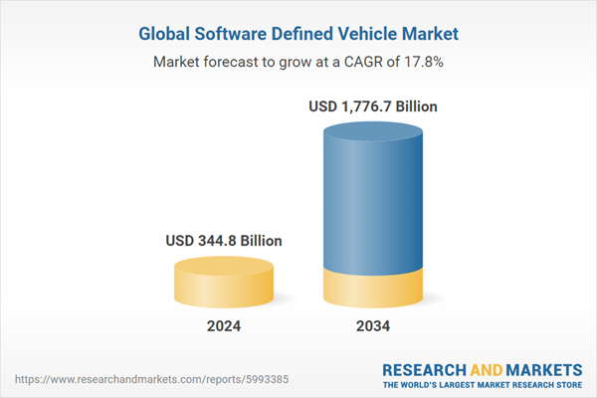
Ultimately, the forecasted growth of the SDV market to USD 1.77 trillion by 2034 emphasizes a fundamental truth: the future of transportation will be defined by software intelligence, connectivity, and adaptability. Vehicles will no longer be static machines but continuously evolving systems capable of learning, communicating, and responding intelligently to their environments—paving the way for a safer, smarter, and more efficient mobility era.
Figure ‎6-1: Market Analysis For SDV Market

Mobility as a Service (MaaS) Market
The rapid expansion of the Mobility as a Service (MaaS) market signifies a global paradigm shift in how people perceive and interact with transportation. Instead of viewing mobility as a privately owned asset, users are increasingly adopting service-based access models — where convenience, affordability, and flexibility take precedence over vehicle ownership. This transformation is being accelerated by advances in digital platforms, IoT connectivity, and real-time data analytics, which together enable seamless integration of various transport modes such as buses, trains, ride-sharing services, bicycles, and autonomous vehicles under a single unified system.
At the core of MaaS lies data-driven mobility orchestration, where artificial intelligence and predictive algorithms analyze traffic flows, commuter preferences, and infrastructure conditions to dynamically optimize travel routes and schedules. This ensures not only reduced congestion and waiting times but also a more energy-efficient use of transportation resources. As cities grow more crowded, MaaS solutions provide a sustainable response to rising urban mobility demands, improving accessibility and reducing dependence on fossil-fuel-powered vehicles.
Furthermore, the evolution of MaaS is closely tied to the ongoing digital transformation of the automotive sector. With the introduction of Software-Defined Vehicles (SDVs), fleets can now be updated, monitored, and managed remotely, enabling flexible deployment and maintenance of shared autonomous vehicles. This synergy allows MaaS operators to offer personalized, adaptive services, where users can select vehicle types, comfort levels, and even entertainment preferences directly through mobile applications.
Another major factor driving MaaS adoption is the increasing integration of smart transportation infrastructure. Through V2I (Vehicle-to-Infrastructure) communication, vehicles can interact with traffic signals, parking systems, and urban control centers, ensuring smoother coordination between public and private mobility services. This interconnectivity supports transportation hubs that act as central nodes — linking various travel options and enabling passengers to transition effortlessly from one mode of transport to another through digital ticketing and automated payment systems.
From an economic standpoint, the MaaS market is creating new revenue models and employment opportunities across technology, transportation, and energy sectors. Startups and established companies alike are investing in cloud-based mobility platforms, autonomous vehicle fleets, and renewable energy-powered charging stations, fostering an entire ecosystem around sustainable, intelligent transport solutions. Governments are also playing a crucial role by supporting smart mobility initiatives, offering subsidies, and enacting regulations that encourage shared and electric mobility adoption.
Moreover, MaaS contributes significantly to environmental and social sustainability goals. By reducing the number of privately owned vehicles on the road, it helps lower greenhouse gas emissions, decrease traffic congestion, and reclaim valuable urban space previously used for parking. Simultaneously, it promotes inclusive mobility, ensuring that people of all economic backgrounds, ages, or abilities can access reliable and affordable transportation options.
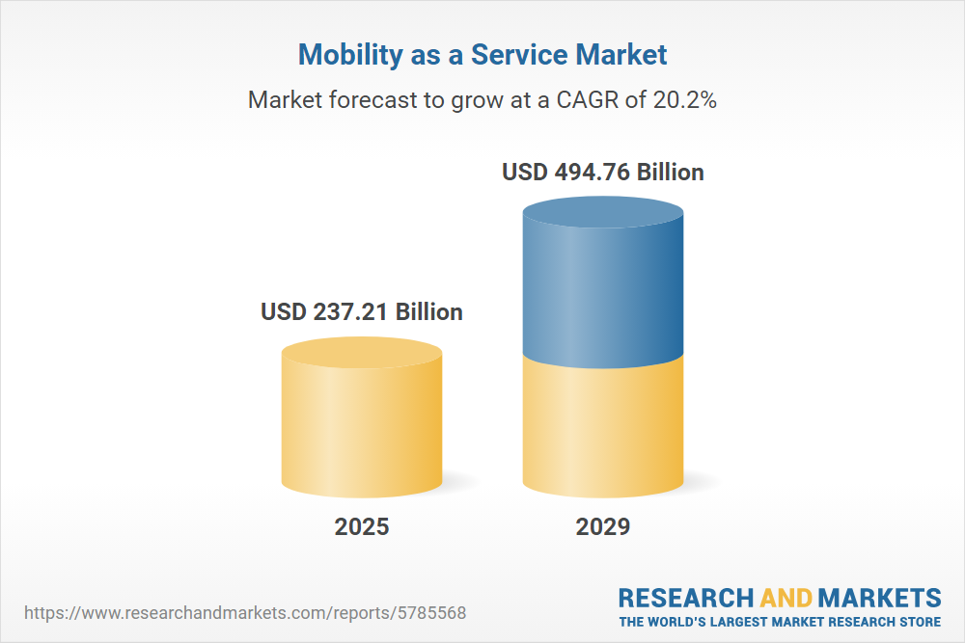
In summary, the projected rise of the MaaS market to USD 494.76 billion by 2029 represents more than just financial growth — it marks a cultural and technological redefinition of mobility itself. When combined with SDV innovations, MaaS becomes a cornerstone of next-generation smart cities, where autonomous, connected, and sustainable transportation networks work in harmony to deliver efficient, accessible, and human-centered mobility experiences.
Figure ‎6-2: Market Analysis for Mobility as a Service Market

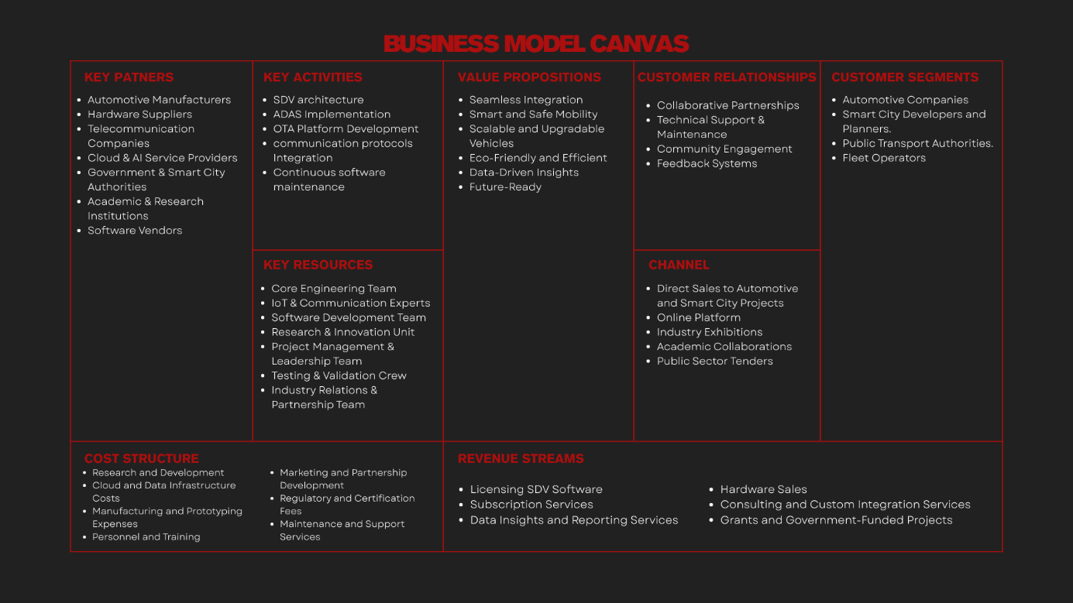
Business Model
Table ‎6-1: Business Model for the Project
The Business Model Canvas defines both the operational and strategic parts of the project. It connects technological innovation with economic feasibility. This ensures every technical part developed, from embedded systems to cloud-based communication, contributes to a clear value proposition and meets real market needs. With this structured approach, the BMC helps understand how the Modular Smart Transportation System can change from a research prototype into a viable solution that can be scaled for real-world use.
In addition, the BMC framework highlights collaboration and ecosystem cooperation. It recognizes that the success of smart transportation depends not just on vehicle technologies, but also on how industry partners, municipalities, and end users interact. By outlining these relationships, the model shows how shared value can come from working together, open innovation, and sustainable business strategies.
In summary, the Business Model Canvas serves as a guide for turning engineering ideas into market-ready innovations. It reflects the overall vision of the project by combining engineering precision with business insight, driving the growth of connected and autonomous mobility in modern cities.

Key Partners
The success of the Modular Smart Transportation System relies on a solid network of key partners who work together across technology, industry, and institutions. This includes automotive manufacturers, who are essential for integrating the system into modern vehicle designs and ensuring it meets current automotive standards. Hardware suppliers provide important components that support the system's modularity, reliability, and performance. Telecommunication companies ensure smooth connectivity and the communication protocols needed for real-time data exchange and coordination within the smart mobility environment.
Cloud and AI service providers make up the digital backbone of the system. They offer the infrastructure for data storage, processing, and smart analytics that help vehicles operate effectively. Government and smart city authorities are also crucial partners. They make sure the project meets public sector regulations, infrastructure plans, and broader urban mobility goals. Collaboration with academic and research institutions strengthens the system's base through research, testing, and ongoing innovation. Finally, software vendors assist in developing and implementing essential tools and platforms that improve system functionality and integration.
Together, these partners create a unified and sustainable ecosystem that allows the Modular Smart Transportation System to progress toward its goal of enabling smart, safe, and future-ready mobility.

Key Activities
The key activities of the Modular Smart Transportation System revolve around the development, integration, and operation of the SDV platform to ensure reliable, intelligent, and connected vehicle performance.
A primary activity is the design and implementation of the SDV architecture, which enables modularity and software-driven control across all vehicle systems. This allows continuous feature enhancement through software updates rather than hardware modifications, ensuring long-term flexibility and scalability.
Another vital activity is the development of ADAS functions, including perception, decision-making, and control modules. These features enhance driving safety and efficiency through real-time sensor fusion and advanced computer vision models.
The project also focuses on building and maintaining OTA infrastructure, covering both FOTA and SOTA updates, to deliver seamless software improvements and system upgrades remotely.
Equally important is the implementation of communication systems, including V2V, V2I, and V2X protocols, enabling interaction between vehicles, infrastructure, and cloud services for coordinated and connected mobility.
In addition, continuous software maintenance, testing, and data analysis are carried out to ensure that system reliability, cybersecurity, and performance remain consistent.
Together, these activities form the operational foundation of the project, ensuring that the Modular Smart Transportation System remains innovative, adaptable, and ready for real-world deployment within the evolving landscape of intelligent transportation.

Key Resources
The success of the Modular Smart Transportation System relies on a diverse team with various skills. This team is backed by strong technical and operational resources.
The engineering team is the project’s main strength. They bring expertise in AI, embedded systems, robotics, IoT, and automotive technologies. Their combined experience helps integrate hardware, software, and communication modules into a cohesive SDV platform.
The research and development team drives innovation and experimentation. They continuously improve perception algorithms, communication protocols, and control strategies to boost system performance and reliability.
A dedicated software development team handles the creation and upkeep of the SDV's operating framework, ADAS algorithms, and data management systems. They ensure these systems are modular and scalable for future applications.
The hardware integration team is responsible for assembling, testing, and calibrating the system's physical components. This includes sensors, controllers, and embedded boards, all to ensure precise and reliable performance.
Supporting these teams are project management and business development staff. They oversee planning, funding, partnerships, and deployment logistics. Their work connects technical results with the larger goals of smart mobility.
Together, these human and technical resources form the foundation of the Modular Smart Transportation System. This collaboration allows it to move from concept to functional implementation, with a clear vision for intelligent, connected, and sustainable transportation.

Value Proposition
The Modular Smart Transportation System offers a new way to think about mobility. It adapts, learns, and scales to meet various needs. This system aims to provide a single solution that improves vehicle performance, safety, and connectivity. It also supports real-time updates and works well within smart city environments.
The system's software-based structure allows vehicles to grow over time through FOTA and SOTA updates. This reduces maintenance costs and extends the life of the products. Its connection with V2X communication ensures smooth interaction between vehicles, infrastructure, and cloud services. This setup helps create safer and more efficient transportation networks.
By using AI-driven ADAS modules, the system improves driving assistance, lane detection, obstacle avoidance, and situational awareness. This leads to higher safety standards and a better experience for users.
Moreover, the modular design of hardware and software offers flexibility for different vehicle models and use cases. This ranges from personal transport to autonomous fleets. This flexibility makes the system well-suited for manufacturers, smart city planners, and research institutions looking to implement new mobility solutions.
In the end, the Modular Smart Transportation System provides an intelligent and future-ready platform that meets the changing needs of modern transportation. It promotes sustainability, reliability, and technological progress.

Customer Relationship
The Modular Smart Transportation System builds a strong, long-lasting relationship with its customers through teamwork, technical help, and ongoing innovation. The system’s main philosophy focuses on trust, openness, and involvement. This ensures that every customer, from manufacturers to end-users, experiences lasting value and satisfaction throughout the product's life.
The project keeps partnerships with vehicle manufacturers, smart city operators, and research institutions through joint development programs and innovation projects. These relationships enable direct feedback and ongoing system improvements based on customer needs.
With dedicated technical support and maintenance services, customers receive real-time system diagnostics, over-the-air updates, and performance monitoring tools. This helps ensure smooth operations and reduces downtime. Additionally, digital communication platforms and dashboards allow clients to track performance metrics, manage updates, and customize system modules to meet their needs.
To promote long-term engagement, the project offers training programs, workshops, and demonstration pilots. These initiatives help stakeholders understand and utilize the system fully. This approach turns customers into strategic partners, fostering shared growth and innovation.
In the end, these relationships are based on continuous improvement, knowledge sharing, and co-creation. This ensures that every partner plays an active role in developing intelligent mobility solutions.

Channels
The Modular Smart Transportation System reaches its stakeholders through a mix of digital, institutional, and industrial channels that ensure smooth communication, integration, and technology transfer. Each channel is crucial for connecting the system’s innovations with its intended users, including government bodies, industry partners, academic collaborators, and smart city developers.
Direct Industry Collaboration serves as a primary channel. It enables joint development, pilot testing, and deployment with automotive manufacturers, IoT companies, and mobility service providers. These partnerships help validate system components under real-world conditions and speed up large-scale adoption.
Academic and Research Partnerships serve as channels for sharing knowledge, refining technical aspects, and validating science. Through joint projects, publications, and conferences, the system’s innovations reach the research community and potential technology users.
Government and Municipal Engagement ensures the system fits into smart city initiatives and urban mobility frameworks. Workshops, policy briefings, and demonstration projects help public stakeholders understand the system’s benefits and support its rollout.
Additionally, digital platforms and online communication channels, including the project’s official website, technical documentation portals, and professional networking sites, offer visibility, technical resources, and access to real-time updates for interested clients and collaborators.
Finally, exhibitions, conferences, and technology expos serve as outreach avenues for showcasing prototypes, demonstrating capabilities, and attracting investors or industrial partners.
These channels connect research, industry, and public sectors, ensuring effective dissemination, adoption, and long-term collaboration.

Customer Segments
The Modular Smart Transportation System serves a diverse range of customer segments spanning industry, government, academia, and technology sectors. Each segment benefits uniquely from the system’s modular, AI-driven, and software-defined capabilities that address the evolving needs of smart mobility ecosystems.
Automotive Manufacturers represent a key segment, leveraging the system’s modular SDV architecture and OTA capabilities to develop next-generation vehicles with enhanced adaptability, safety, and performance. The platform enables manufacturers to accelerate digital transformation and reduce dependency on traditional hardware modifications.
Smart City and Government Agencies form another vital segment, utilizing the system to modernize urban mobility infrastructure, integrate intelligent transportation services, and promote sustainable city development. By adopting the system, municipalities can enhance traffic management, reduce emissions, and improve overall mobility efficiency.
Public Transportation Operators and Fleet Managers benefit through real-time monitoring, predictive maintenance, and V2X-enabled coordination that optimizes route planning and operational efficiency while lowering long-term costs.
Research Institutions and Universities engage with the system as a technological and educational platform for experimentation, simulation, and interdisciplinary research in AI, IoT, and transportation systems.
Finally, Technology Developers and Integrators — including startups and software firms — represent a dynamic segment that can build upon the system’s open interfaces and APIs to create customized solutions and expand its ecosystem.
Through these diverse segments, the system maintains a balanced approach — supporting innovation, commercialization, and societal advancement across multiple layers of the mobility landscape.

Cost Structure
The cost structure of the Modular Smart Transportation System reflects a balanced distribution of expenses across research, development, operations, and partnership maintenance. It ensures that financial resources are allocated efficiently to support both innovation and long-term sustainability.
Research and Development (R&D) Costs form a major portion of the budget, covering prototype design, system integration, software development, and testing of SDV modules, AI models, and embedded systems. Continuous R&D investment ensures that the system remains aligned with emerging technologies and industry standards.
Hardware and Infrastructure Costs include the acquisition of sensors, controllers, edge devices, and communication modules used in vehicle and IoT integration. Additionally, infrastructure spending extends to cloud platforms and data servers that support OTA updates, analytics, and real-time processing.
Human Resources and Expertise represent another significant component, encompassing the engineering, design, and management teams responsible for technical development, deployment, and support. Skilled personnel are essential for maintaining quality and innovation across all project stages.
Operational and Maintenance Costs cover system monitoring, software updates, and continuous improvement of services. These ensure high system reliability and long-term functionality.
Partnership and Collaboration Costs arise from engagements with automotive manufacturers, technology vendors, academic institutions, and government agencies — covering licensing, joint research programs, and integration efforts.
Marketing and Deployment Costs are also included, relating to awareness campaigns, pilot projects, and participation in smart mobility initiatives to demonstrate system effectiveness and attract potential stakeholders.
Overall, the cost structure emphasizes sustainable growth by strategically investing in innovation, infrastructure, and human capital while minimizing redundant or non-scalable expenditures.

Revenue Streams
The Modular Smart Transportation System creates value through a variety of revenue streams that focus on long-term financial health and growth. These streams are designed to reflect the technology behind the system and its possible uses in public, private, and industrial areas.
Licensing and Software Subscriptions are a major source of income. They give access to the SDV platform, control algorithms, and communication modules. Organizations can choose from different subscription levels that provide various features, analytics, and support.
System Integration and Deployment Services generate revenue by offering tailored implementation for car manufacturers, local governments, and transport operators. These services include setting up hardware, calibrating embedded systems, and integrating OTA and V2X communication features.
Data Services and Analytics contribute another important revenue stream. They provide access to real-time vehicle data, performance insights, and traffic analytics. This information aids in smart city planning, predictive maintenance, and transportation management.
Maintenance and Support Contracts create a steady revenue flow by providing ongoing system updates, diagnostics, and technical help. These contracts ensure reliable performance and foster long-term customer relationships.
Partnership-Based Revenue comes from working with technology providers, cloud platforms, and infrastructure developers. Shared investment or co-development models create mutual financial gain while lowering operational risks.
Educational and Research Collaborations also offer revenue through partnerships with academic institutions, workshops, and prototype testing funded by research grants or innovation projects.
In summary, the revenue structure balances direct sales with ongoing income and revenue from partnerships. This approach ensures the system remains profitable while continuing to drive innovation in smart transportation.

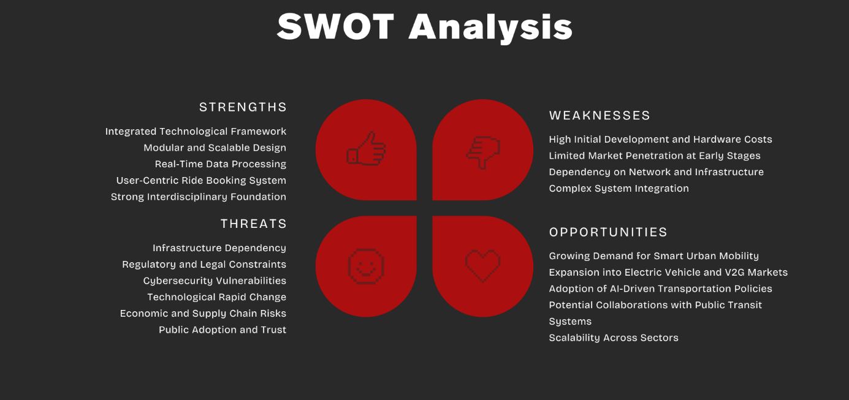
SWOT Analysis
Table ‎6-2: SWOT Analysis For the Project
The SWOT Analysis provides a comprehensive overview of the internal and external factors influencing the development and sustainability of the Modular Smart Transportation System. It helps identify the project’s strengths and weaknesses while highlighting potential opportunities and threats within the evolving landscape of intelligent mobility. This analysis serves as a strategic tool to ensure the system’s long-term viability, adaptability, and alignment with the future of smart urban infrastructure.

Strengths
The project’s main strengths are its integrated technology framework and modular, scalable design. Together, these features enable flexibility in various urban environments. The system processes data in real time, allowing for smooth traffic management, predictive routing, and efficient use of resources. Its ride booking feature focuses on users, making it convenient and accessible. This provides a seamless experience that connects public and private transport.
Additionally, the project has a solid foundation built on collaboration among experts in AI, IoT, embedded systems, and transportation engineering. This teamwork promotes ongoing innovation and strong performance. The system's modular design makes it easy to integrate with new technologies like V2X communication and renewable-powered fleets. This ensures it remains relevant and sustainable in the changing smart mobility landscape.

Weaknesses
Despite its strong foundation, the system faces several challenges that need to be managed carefully. High initial development and hardware costs can hinder large-scale implementation, especially during early deployment phases when funding and partnerships are still being set up. Limited market penetration at the beginning may also slow user adoption until pilot programs and demonstrations clearly show the system’s reliability, safety, and efficiency.
Additionally, the system’s reliance on strong communication networks and digital infrastructure poses a challenge in areas where connectivity is inconsistent or outdated. The complexity of integrating multiple components, including SDV platforms, IoT networks, and smart infrastructure, adds to operational difficulty and requires specialized expertise. These challenges highlight the need for effective scaling strategies, ongoing improvement, and collaborative partnerships to ensure smooth and sustainable implementation in different urban settings.

Opportunities
The rapid global shift toward smart urban mobility offers many opportunities for the project's growth and influence. Increased investments in electric vehicle infrastructure and V2G (Vehicle-to-Grid) systems create avenues for smooth integration with renewable energy grids. This supports environmental sustainability and improves operational efficiency. Also, the rising use of AI-driven transportation policies by governments around the world creates a supportive regulatory environment that promotes innovation and widespread deployment.
In addition, partnerships with public transit authorities and city planners can help create integrated, multimodal mobility systems where private, public, and shared transport work together. The project's scalable and flexible design enables it to meet the needs of various sectors, from city fleets to university campuses and industrial sites. Together, these opportunities make the system not just a transportation solution but a key part of developing future smart cities and intelligent mobility infrastructure.

Threats
The system’s success is affected by several outside threats that must be dealt with to ensure long-term sustainability. Dependency on infrastructure remains a key concern because the system’s effectiveness depends on stable connectivity, smart road networks, and strong cloud infrastructure. These elements may be limited in developing urban areas. Regulatory and legal issues complicate deployment. Different regional policies on data privacy, autonomous systems, and communication standards could delay large-scale implementation.
Cybersecurity vulnerabilities also present a constant risk, especially with the system’s reliance on V2X networks and cloud-based data processing. These challenges require strong encryption protocols, intrusion detection tools, and regular system audits to keep public trust. The fast pace of technological change puts additional pressure for continuous updates. New communication standards or AI models might make current components outdated.
Lastly, economic changes and public perception are crucial. Unstable markets can limit investment and resources, while hesitation or distrust of automation may hinder adoption. Handling these threats with foresight, transparency, and ongoing improvement will be essential for the project’s long-term strength and credibility.

Sustainable Development Goals


Figure ‎6-3: SDGs for the Project
The Modular Smart Transportation System aligns with the global vision of the United Nations Sustainable Development Goals (SDGs), which serve as a universal framework for achieving a more sustainable, inclusive, and innovative future. By integrating advanced technologies such as AI, IoT, and embedded systems into modern transportation, the project contributes to several key objectives that promote economic growth, industrial innovation, sustainable urban development, and collaborative partnerships. This alignment not only reinforces the project’s technical and societal relevance but also demonstrates its commitment to addressing global challenges through intelligent, efficient, and environmentally conscious mobility solutions.

SDG 8 – Decent Work and Economic Growth
The project encourages economic growth by promoting innovation in transportation and technology. It generates skilled job opportunities in areas like AI, embedded systems, and IoT development, while also supporting sustainable industrial progress through smart mobility solutions. By backing research, entrepreneurship, and local production of smart vehicle parts, the system helps build knowledge-based economies and boosts the competitiveness of emerging markets. This leads to long-term economic stability and supports global efforts for inclusive and sustainable growth.

SDG 9 – Industry, Innovation, and Infrastructure
At the core of the project is the aim to build strong infrastructure and promote innovation. The system updates transportation with software-defined vehicles, smart sensors, and IoT communication networks. This drives progress toward a more connected and tech-savvy mobility ecosystem. By combining powerful computing, AI decision systems, and flexible communication frameworks, it reinforces urban infrastructure and supports ongoing innovation in both hardware and software. This method improves operational efficiency and safety. It also supports sustainable industrial growth by connecting new technologies to real-world uses.

SDG 11 – Sustainable Cities and Communities
The project aims to create smart and sustainable urban environments. It reduces traffic congestion, improves transport efficiency, and connects vehicle systems within city infrastructure. This work raises living standards in cities and helps make communities safer, cleaner, and more accessible. Through smart mobility management and data-driven insights, the system promotes efficient energy use, lessens environmental impact, and coordinates public transport better. By focusing on inclusivity, it ensures that mobility services are available to all citizens. This approach supports fair urban development and opens the door for future smart city innovations that balance technology, sustainability, and quality of life.


Egypt Vision 2030 and Digital Transformation
Figure ‎6-4: Egypt Vision 2030
Egypt Vision 2030 is a national plan focused on achieving sustainable development in economic, social, and environmental areas. It highlights innovation, upgrading infrastructure, and digital changes as essential for progress. The vision aims to make Egypt a regional leader in smart industries, green transportation, and technology-driven government, all backed by a strong digital economy.
The Modular Smart Transportation System directly supports these national goals by incorporating advanced technologies like AI, IoT, embedded systems, and software-defined vehicles into urban transportation. With smart connectivity and automation, the system aids the digital transformation of transport, leading to safer roads, less traffic, and better operational efficiency.
By allowing V2X communication, real-time data analysis, and automated decision-making, the project creates a foundation for smarter mobility that aligns with Egypt’s broader goals of sustainable cities and digital access. It encourages teamwork among schools, businesses, and government agencies, creating an innovation-driven environment that boosts the national digital economy.
Additionally, this project helps Egypt move toward clean and efficient transportation, supporting the green economy aspect of Vision 2030. Its modular design makes it possible to integrate electric vehicles, renewable energy systems, and smart city designs in the future, ensuring long-term flexibility and support for the country’s sustainability goals.
In short, the Modular Smart Transportation System is more than just a technical improvement. It is a key step toward achieving Egypt’s Vision 2030, where digital shifts and sustainable growth come together to create a more connected, intelligent, and successful future.

CHAPTER 7
Conclusion

Chapter (7) Conclusion
The Modular Smart Transportation System demonstrates a robust and scalable framework for implementing Software-Defined Vehicles (SDVs) in modern urban environments. This project successfully integrates a wide range of hardware components, including the Raspberry Pi 5, ATmega32A, ESP32, IMU 9DoF, ultrasonic sensors, GPS modules, LCD displays, and cameras, creating a flexible platform capable of supporting autonomous driving, real-time perception, and intelligent vehicle communication.
The development of the ADAS system enables the vehicle to perform essential perception tasks, such as object detection, lane detection, vehicle distance measurement, and traffic sign recognition, utilizing both RGB and depth sensing. The modular design ensures seamless coordination between microcontrollers, sensors, and high-level computation on the Raspberry Pi 5, allowing reliable real-time decision-making and precise vehicle control under dynamic conditions.
The integration of the ESP32 enhances the system’s connectivity by supporting V2V, V2I, and V2X communication, allowing the SDV to interact effectively with other vehicles, transportation infrastructure, and the urban traffic ecosystem. This networked capability improves situational awareness, facilitates cooperative driving scenarios, and demonstrates the vehicle’s ability to operate as an intelligent participant within a connected urban environment.
The project also includes a ride booking mobile application, providing a seamless and intuitive interface for users to interact directly with the vehicle. Passengers can submit ride requests, track vehicle location, and receive real-time updates, demonstrating the practical application of a connected transportation service. The application emphasizes usability, accessibility, and intuitive navigation, reflecting a human-centered approach to urban mobility that aligns with modern smart city concepts.
From a system perspective, the ATmega32A microcontroller handles time-critical and low-level operations, such as sensor data acquisition and actuator control, while the Raspberry Pi 5 executes computationally intensive tasks, including ADAS inference, sensor fusion, and decision-making algorithms. This separation of responsibilities ensures efficient task management, low-latency responses, and reliable operation, which are critical for safety and performance in autonomous vehicle systems.
The project demonstrates effective modularity, enabling easy integration of new hardware components, sensors, and software modules without requiring significant redesign. This flexibility allows the platform to adapt to various applications, including urban ride-hailing, autonomous delivery, and experimental autonomous driving research. The combination of modular hardware, high-level software orchestration, and robust communication frameworks positions this SDV platform as a comprehensive solution for intelligent and connected transportation.
Overall, the project validates the feasibility of a modular, intelligent, and connected vehicle platform, showing how the integration of sensors, embedded systems, perception algorithms, and communication networks can create a safe, reliable, and efficient urban transportation solution. By demonstrating practical implementation in a real-world context, the system establishes a solid foundation for future research, development, and deployment of autonomous and connected mobility solutions, highlighting the potential for smart, scalable, and human-centered transportation in modern cities.

CHAPTER 8
Future Work

Chapter (8) Future Work

Introduction
The Modular Smart Transportation System presents a scalable and modular framework for smart vehicles in urban environments. While the current implementation achieves significant milestones in ADAS, external perception, and vehicle-to-everything communication, there remains substantial potential for further development. Future work aims to enhance the system’s efficiency, safety, intelligence, and sustainability, aligning it with emerging trends in autonomous and connected transportation.
These enhancements not only target technical improvements such as more accurate perception, optimized decision-making, and advanced communication protocols, but also focus on user experience and integration with urban infrastructure. By adopting advanced hardware, innovative software models, and smarter interfaces, the system can better handle complex traffic scenarios, ensure higher reliability in real-time operations, and provide a more seamless and intuitive experience for both operators and passengers.
Furthermore, incorporating eco-friendly technologies and sustainable energy solutions, such as electric vehicle propulsion and vehicle-to-grid integration, positions the SDV platform as a forward-looking solution compatible with smart city initiatives and green mobility objectives. The modular design of the system ensures that future additions, whether in perception, communication, or user interaction, can be implemented without disrupting existing functionalities, maintaining flexibility and scalability.
In the following sections, the proposed future enhancements are outlined, highlighting their purpose, benefits, and contribution to creating a safer, smarter, and more sustainable modular transportation system.

Implementation of EV
The SDV platform can be adapted to electric propulsion systems (EVs), replacing conventional internal combustion engines with clean and efficient electric drivetrains. Implementing an EV not only enhances environmental sustainability by reducing greenhouse gas emissions and dependence on fossil fuels but also lowers operational costs, including fuel expenses and maintenance requirements, due to fewer moving parts and regenerative braking capabilities.
The modular architecture of the SDV allows for seamless integration of advanced battery management systems (BMS), which monitor state-of-charge, temperature, and overall health of the battery pack to ensure optimal performance and longevity. Regenerative braking systems recover energy during deceleration, further improving energy efficiency and extending driving range. Additionally, the electric propulsion setup supports intelligent energy distribution, prioritizing power between the drivetrain, onboard sensors, communication modules, and other vehicle subsystems, ensuring consistent performance without overloading any component.
Adopting an EV platform also opens opportunities for integration with renewable energy sources, smart charging stations, and vehicle-to-grid (V2G) technologies, enabling the SDV to interact dynamically with the power grid and contribute to sustainable urban energy management. Furthermore, EVs provide a quieter and smoother driving experience, reducing noise pollution and improving passenger comfort, which complements the SDV’s advanced autonomous and connected capabilities.
By transitioning to an electric platform, the SDV not only becomes more eco-friendly and cost-efficient, but also positions itself for future-ready urban mobility, aligning with global trends in smart cities, sustainable transport, and autonomous electric vehicles. This transition lays a solid foundation for subsequent enhancements in sensor integration, energy management, and intelligent transportation services, ensuring that the modular system remains adaptable, efficient, and scalable.

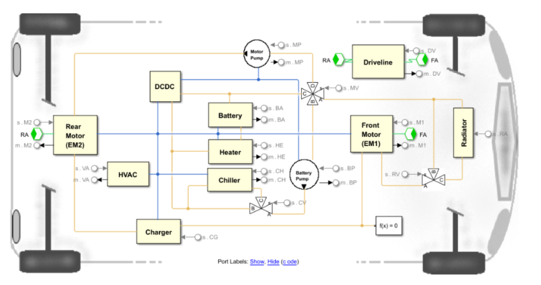
Simulations of MATLAB EV Design with Simscape
Figure ‎8-1: Design of the electric propulsion systems
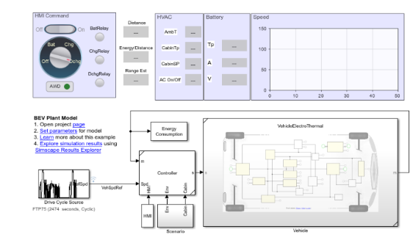
Figure ‎8-2: Drive Range Estimator Model

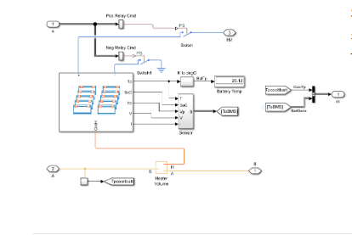
Figure ‎8-3: Size Battery Model

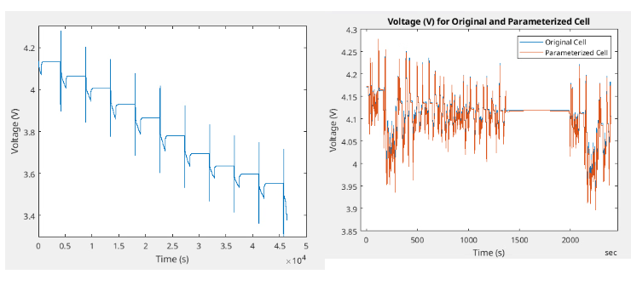
Figure ‎8-4: Battery Characterization Using HPPC Test Data

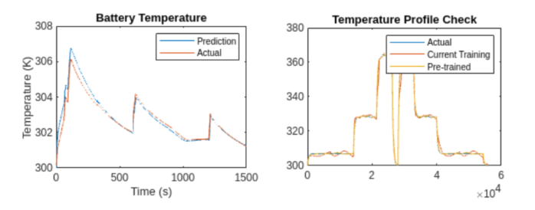
Figure ‎8-5: Visualization of Neural Network Model That Predicts Battery Temprature

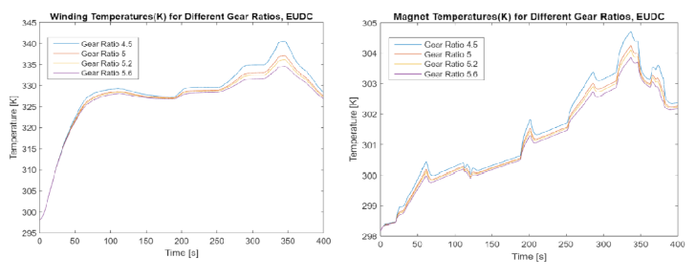
Figure ‎8-6: Efficient Gear Ratio For Electric Drive DoE

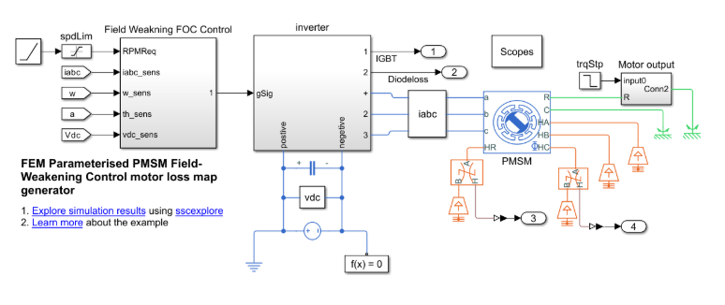
Figure ‎8-7: Electric Motor Test Bench For System Integration Model

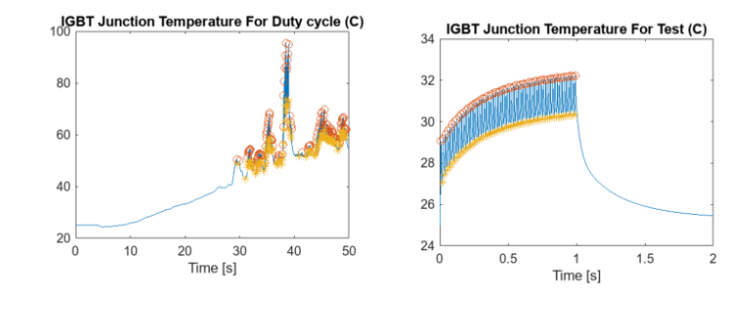
Figure ‎8-8: Electric Drive Durability and Life Verification Model

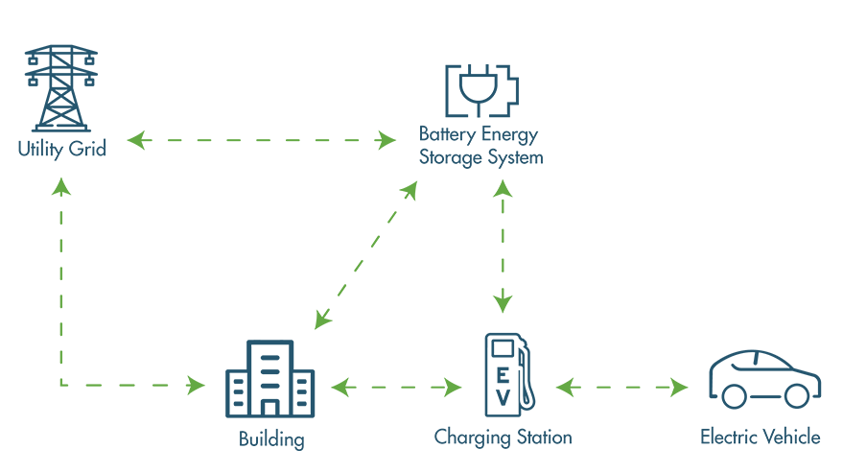
Vehicle-to-Grid (V2G) Communication
Figure ‎8-9: Vehicle-to-Grid (V2G) Communication Methodology
By implementing Vehicle-to-Grid (V2G) technology, the SDV can bi-directionally exchange energy with the electrical grid, enabling the vehicle to act not only as a mobile energy consumer but also as a distributed energy resource. During periods of peak electricity demand, surplus energy stored in the vehicle’s battery can be fed back into the grid, helping to stabilize grid frequency, reduce load stress, and prevent outages. Conversely, during off-peak periods or when renewable energy availability is high, the SDV can recharge its batteries at lower cost, optimizing energy efficiency and reducing dependency on fossil-fuel-generated power.
V2G integration enhances overall energy management by enabling intelligent scheduling of charging and discharging cycles. Advanced algorithms can determine optimal times for energy exchange, considering electricity prices, battery health, vehicle usage patterns, and grid demand. This not only reduces operational costs for vehicle owners but also contributes to dynamic energy balancing in smart cities, supporting the integration of intermittent renewable sources such as solar and wind power.
From a system perspective, V2G adds a layer of interaction between the transportation network and urban infrastructure, allowing SDVs to participate actively in energy markets or local microgrids. This capability transforms vehicles into mobile energy hubs, increasing the flexibility and resilience of both the transportation and power systems.
Additionally, V2G can complement the SDV’s electric propulsion system, ensuring that energy consumption is optimized across propulsion, sensors, ADAS modules, and communication devices. By aligning vehicle energy management with smart grid capabilities, V2G enhances sustainability, economic efficiency, and operational reliability, positioning the Modular Smart Transportation System as a forward-looking platform for eco-friendly, connected, and intelligent urban mobility.

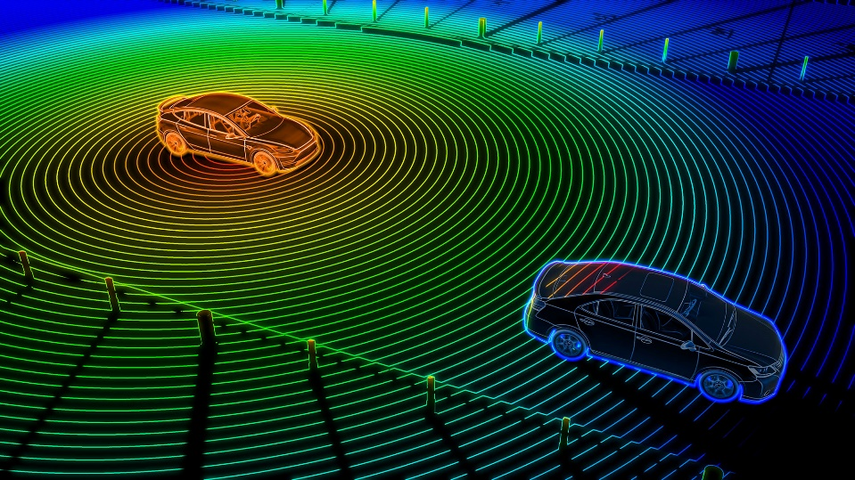
More Optimized and Accurate Visual Perception using LiDAR
Figure ‎8-10: LiDAR Point Cloud Coordinate Reference
Future work includes integrating LiDAR sensors alongside the existing camera systems to enhance object detection, lane recognition, and distance measurement. LiDAR provides precise 3D point clouds, enabling the vehicle to capture the shape, size, and spatial positioning of surrounding objects with high accuracy. This complements RGB and depth data from cameras, improving visual perception in low-light conditions, complex urban scenarios, and adverse weather, such as fog, rain, or glare, where cameras alone may struggle.
Integrating LiDAR into the Modular Smart Transportation System will allow for advanced sensor fusion, combining LiDAR, cameras, ultrasonic sensors, and IMU data to create a robust and comprehensive environmental model. This multi-sensor approach ensures higher reliability, redundancy, and safety, allowing the ADAS system to detect obstacles, vehicles, pedestrians, and lane boundaries more accurately and consistently in real time.
Additionally, LiDAR enables the SDV to perform precise distance measurement and 3D mapping, which can be leveraged for trajectory planning, collision avoidance, and predictive navigation. By generating accurate point clouds of the surrounding environment, the system can anticipate potential hazards, adjust vehicle speed, and optimize lane changes safely and efficiently.
From a system perspective, integrating LiDAR enhances autonomous driving capabilities by supporting real-time decision-making and dynamic response to complex road conditions. It also facilitates long-range perception, providing the SDV with the ability to detect distant objects and obstacles that may not be visible to cameras or ultrasonic sensors, contributing to safer navigation at higher speeds.
Overall, the addition of LiDAR will significantly increase the accuracy, reliability, and robustness of the ADAS perception system, making the SDV platform better equipped to operate in diverse and challenging urban and highway environments, and paving the way for more advanced autonomous and semi-autonomous functionalities.

Enhanced FOTA/SOTA Delivery using FogNet and Roadside Units (RSU)
Future work can incorporate Fog Computing Networks (FogNet) and Roadside Units (RSUs) to enhance Firmware Over-the-Air (FOTA) and Software Over-the-Air (SOTA) updates for the SDV. By leveraging FogNet, computation and storage resources are distributed closer to the vehicles, reducing latency, improving reliability, and minimizing dependence on distant cloud servers. RSUs act as local communication hubs along roadways, providing high-bandwidth, low-latency connections that enable real-time data exchange and update delivery as vehicles move through the transportation network.
This approach ensures that critical firmware and software updates can be delivered efficiently and securely, even in dense urban environments or areas with intermittent connectivity. By deploying updates via FogNet and RSUs, the SDV system can maintain up-to-date ADAS models, perception algorithms, and communication protocols, supporting optimal vehicle performance and safety.
Additionally, integrating FogNet and RSUs allows for context-aware update scheduling, where updates can be prioritized based on vehicle location, current network load, and operational requirements. This reduces downtime and ensures that vehicles remain fully functional while receiving the latest improvements. The approach also supports scalability, enabling a growing fleet of SDVs to receive updates simultaneously without overloading central servers.
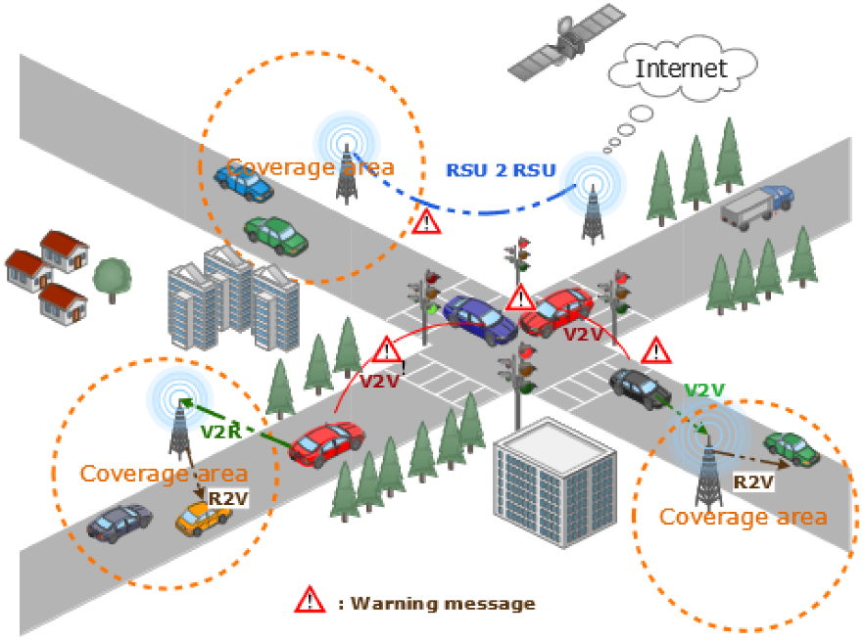
Overall, using FogNet in combination with RSUs provides a robust, low-latency, and secure framework for continuous FOTA/SOTA delivery, ensuring that the Modular Smart Transportation System remains adaptive, efficient, and future-ready in rapidly evolving urban environments.
Figure ‎8-11: Roadside Unit Deployment
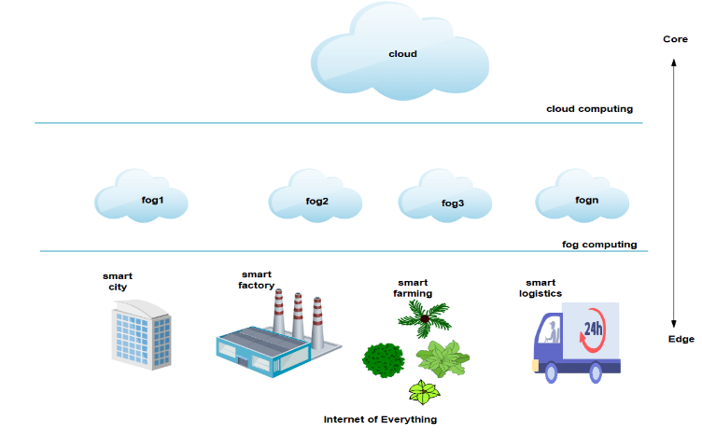
Figure ‎8-12: FogNet vs Cloud Computing Architecture

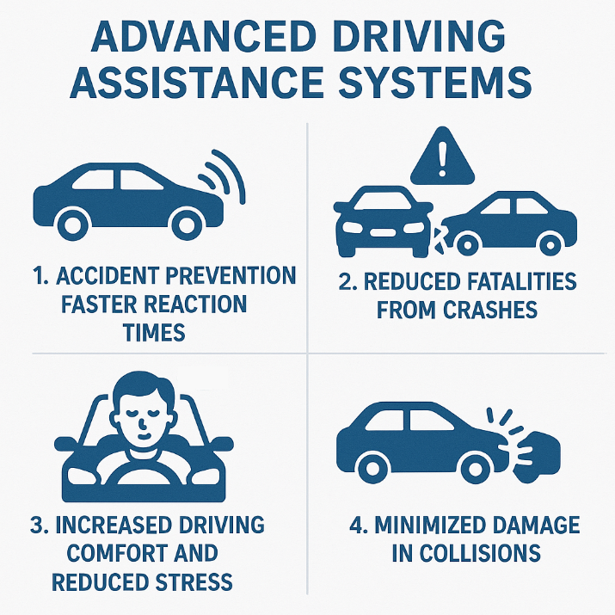
Implementing Additional Computer Vision Models in ADAS
Figure ‎8-13: ADAS Structure
The ADAS (Advanced Driver-Assistance System) currently utilizes YOLOv8 for real-time object detection and environmental perception. Future work aims to expand upon this foundation by integrating additional computer vision models to enhance the vehicle’s ability to recognize and respond to a broader range of on-road scenarios.
These models may include those designed for road condition analysis, pedestrian gesture recognition, vehicle type classification, and complex traffic sign interpretation. By incorporating these specialized networks alongside YOLOv8, the system can achieve multi-layered perception—allowing it to interpret not just static objects, but also dynamic interactions within its surroundings.
To further enhance performance, the integration of semantic segmentation and depth estimation models can provide a richer understanding of the driving environment. This would allow the SDV to distinguish between road surfaces, obstacles, and moving entities more precisely, improving decision-making in adaptive cruise control, lane keeping, and collision avoidance scenarios.
In addition, model optimization techniques such as quantization, knowledge distillation, and hardware acceleration can be employed to ensure real-time inference on embedded platforms like the Raspberry Pi 5. These optimizations will maintain high detection accuracy while minimizing computational load and power consumption.
By building upon the existing YOLOv8-based perception pipeline and expanding it with new, specialized models, the ADAS will evolve into a more adaptive, context-aware, and intelligent vision system. This continuous development will enhance the SDV’s overall perception, safety, and autonomy—paving the way toward fully autonomous operation in complex smart city environments.

Enhancing the Ride Booking Mobile Application with V2I Communication
The ride booking application can be extended to communicate directly with vehicles via V2I (Vehicle-to-Infrastructure) communication. This allows transportation hubs to send ride requests, route updates, and real-time instructions directly to the vehicle, reducing response times, optimizing routing, and improving passenger experience through seamless integration between the app and the SDV.
In this architecture, the SDV acts as an intelligent node within the smart city ecosystem. Through secure V2I channels, the vehicle can receive prioritized traffic data, weather alerts, and congestion information from roadside units (RSUs) and fog nodes, allowing for predictive route planning and dynamic re-routing. Furthermore, this system can support autonomous dispatching — where vehicles automatically reposition themselves to high-demand areas based on historical data and predictive analytics.
To enhance user interaction, the mobile app could provide real-time vehicle status, estimated arrival times, and eco-mode suggestions (e.g., selecting routes with optimal energy efficiency). Integration with the city’s digital infrastructure also opens opportunities for coordinated fleet management, shared mobility, and adaptive pricing based on demand and traffic density.
Finally, coupling the V2I system with edge AI and FogNet technology ensures ultra-low latency communication for mission-critical tasks, such as obstacle alerts or emergency route adjustments, thereby enhancing safety, operational efficiency, and user satisfaction.


Enhancing the Interfaces of the Ride Booking App using Figma
Figure ‎8-14: Figma
Future improvements include redesigning the mobile application interface using Figma, focusing on user experience, accessibility, and intuitive navigation. The redesigned interface will adopt a modular design approach, ensuring consistent aesthetics across devices and screen sizes while maintaining usability for all passengers, including those with accessibility needs. Enhanced UI/UX principles, such as responsive layouts, minimal user flow friction, and context-aware elements, will help users effortlessly book rides, track vehicles, and receive real-time notifications.
Moreover, integrating interactive dashboards will allow users to view detailed trip analytics, estimated costs, and carbon footprint data, promoting eco-conscious travel decisions. Personalized service recommendations powered by AI-based user profiling could offer optimized routes, preferred vehicle types, or subscription plans tailored to individual habits.
The app redesign also opens the door for multi-language support, dark mode integration, and offline usability to ensure reliability in areas with limited connectivity. Combined with backend improvements like secure authentication, data encryption, and cloud synchronization, the upgraded interface will deliver a seamless and secure experience — positioning the mobile application as an essential component of the smart transportation ecosystem.


Implementing Embedded Linux
Figure ‎8-15: Linux
Future work includes implementing Embedded Linux on the SDV’s onboard computing platforms, such as the Raspberry Pi 5. By transitioning from standard operating environments to a tailored Embedded Linux distribution, the system can achieve higher performance, stability, and resource efficiency for real-time control, perception processing, and communication tasks.
Embedded Linux provides a lightweight, customizable operating system that can be optimized for the SDV’s hardware constraints. It allows direct access to hardware interfaces, low-latency execution of critical processes, and improved management of memory and CPU resources. This is particularly beneficial for running complex ADAS inference models, sensor fusion algorithms, and V2X communication protocols without performance bottlenecks.
The adoption of Embedded Linux also facilitates modular software deployment, enabling features like FOTA/SOTA updates, over-the-network monitoring, and secure system logging. Its compatibility with open-source libraries, drivers, and frameworks allows seamless integration of peripherals, including cameras, LiDAR, IMU, GPS, and communication modules such as the ESP32.
Furthermore, Embedded Linux supports advanced process scheduling and multitasking, ensuring that real-time tasks (e.g., sensor data acquisition, vehicle control, and perception processing) are executed reliably alongside communication and auxiliary services. This guarantees consistent system responsiveness, which is critical for safety and autonomous operations.
By implementing Embedded Linux, the SDV platform will achieve a robust, scalable, and efficient software backbone, laying the groundwork for future enhancements in autonomous driving, intelligent transportation services, and smart city integration.

REFERENCES

References
[1] A. A. Brincat, F. Pacifici, S. Martinaglia, and F. Mazzola, “The Internet of Things for Intelligent Transportation Systems in Real Smart Cities Scenarios,” in 2019 IEEE 5th World Forum on Internet of Things (WF-IoT), 2019, pp. 128–132. doi: 10.1109/WF-IoT.2019.8767247.
[2] R. Faria, L. Brito, K. Baras, and J. Silva, “Smart mobility: A survey,” in 2017 International Conference on Internet of Things for the Global Community (IoTGC), 2017, pp. 1–8. doi: 10.1109/IoTGC.2017.8008972.
[3] Z. Mahrez, E. Sabir, E. Badidi, W. Saad, and M. Sadik, “Smart Urban Mobility: When Mobility Systems Meet Smart Data,” IEEE Transactions on Intelligent Transportation Systems, vol. 23, no. 7, pp. 6222–6239, 2022, doi: 10.1109/TITS.2021.3084907.
[4] G. Solmaz et al., “Toward Understanding Crowd Mobility in Smart Cities through the Internet of Things,” IEEE Communications Magazine, vol. 57, no. 4, pp. 40–46, 2019, doi: 10.1109/MCOM.2019.1800611.
[5] A. Pundir, S. Singh, M. Kumar, A. Bafila, and G. J. Saxena, “Cyber-Physical Systems Enabled Transport Networks in Smart Cities: Challenges and Enabling Technologies of the New Mobility Era,” IEEE Access, vol. 10, pp. 16350–16364, 2022, doi: 10.1109/ACCESS.2022.3147323.
[6] Y. Mehmood, F. Ahmad, I. Yaqoob, A. Adnane, M. Imran, and S. Guizani, “Internet-of-Things-Based Smart Cities: Recent Advances and Challenges,” IEEE Communications Magazine, vol. 55, no. 9, pp. 16–24, 2017, doi: 10.1109/MCOM.2017.1600514.
[7] I. Yaqoob, I. A. T. Hashem, Y. Mehmood, A. Gani, S. Mokhtar, and S. Guizani, “Enabling Communication Technologies for Smart Cities,” IEEE Communications Magazine, vol. 55, no. 1, pp. 112–120, 2017, doi: 10.1109/MCOM.2017.1600232CM.
[8] S. Goumiri, S. Yahiaoui, and S. Djahel, “Smart Mobility in Smart Cities: Emerging challenges, recent advances and future directions,” J Intell Transp Syst, vol. 29, no. 1, pp. 81–117, Jan. 2025, doi: 10.1080/15472450.2023.2245750.
[9] A. H. Alavi, P. Jiao, W. G. Buttlar, and N. Lajnef, “Internet of Things-enabled smart cities: State-of-the-art and future trends,” Measurement, vol. 129, pp. 589–606, 2018, doi: https://doi.org/10.1016/j.measurement.2018.07.067.
[10] S. G. Farag, “Application of Smart Structural System for Smart Sustainable Cities,” in 2019 4th MEC International Conference on Big Data and Smart City (ICBDSC), 2019, pp. 1–5. doi: 10.1109/ICBDSC.2019.8645582.
[11] C. K. Toh, J. A. Sanguesa, J. C. Cano, and F. J. Martinez, “Advances in smart roads for future smart cities,” Proceedings of the Royal Society A: Mathematical, Physical and Engineering Sciences, vol. 476, no. 2233, p. 20190439, Jan. 2020, doi: 10.1098/rspa.2019.0439.
[12] K. Ota, T. Kumrai, M. Dong, J. Kishigami, and M. Guo, “Smart Infrastructure Design for Smart Cities,” IT Prof, vol. 19, no. 5, pp. 42–49, 2017, doi: 10.1109/MITP.2017.3680957.
[13] S. Djahel, N. Jabeur, R. Barrett, and J. Murphy, “Toward V2I communication technology-based solution for reducing road traffic congestion in smart cities,” in 2015 International Symposium on Networks, Computers and Communications (ISNCC), 2015, pp. 1–6. doi: 10.1109/ISNCC.2015.7238584.
[14] G. A. Ubiergo and W.-L. Jin, “Mobility and environment improvement of signalized networks through Vehicle-to-Infrastructure (V2I) communications,” Transp Res Part C Emerg Technol, vol. 68, pp. 70–82, 2016, doi: https://doi.org/10.1016/j.trc.2016.03.010.
[15] W. He et al., “Overview of V2V and V2I Wireless Communication for Cooperative Vehicle Infrastructure Systems,” in 2019 IEEE 4th Advanced Information Technology, Electronic and Automation Control Conference (IAEAC), 2019, pp. 127–134. doi: 10.1109/IAEAC47372.2019.8997786.
[16] L. Hobert, A. Festag, I. Llatser, L. Altomare, F. Visintainer, and A. Kovacs, “Enhancements of V2X communication in support of cooperative autonomous driving,” IEEE Communications Magazine, vol. 53, no. 12, pp. 64–70, 2015, doi: 10.1109/MCOM.2015.7355568.
[17] A. Alnasser, H. Sun, and J. Jiang, “Cyber security challenges and solutions for V2X communications: A survey,” Computer Networks, vol. 151, pp. 52–67, 2019, doi: https://doi.org/10.1016/j.comnet.2018.12.018.
[18] M. Hasan, S. Mohan, T. Shimizu, and H. Lu, “Securing Vehicle-to-Everything (V2X) Communication Platforms,” IEEE Transactions on Intelligent Vehicles, vol. 5, no. 4, pp. 693–713, 2020, doi: 10.1109/TIV.2020.2987430.
[19] M. I. Ashraf, M. Bennis, C. Perfecto, and W. Saad, “Dynamic Proximity-Aware Resource Allocation in Vehicle-to-Vehicle (V2V) Communications,” in 2016 IEEE Globecom Workshops (GC Wkshps), 2016, pp. 1–6. doi: 10.1109/GLOCOMW.2016.7848885.
[20] A. Demba and D. P. F. Möller, “Vehicle-to-Vehicle Communication Technology,” in 2018 IEEE International Conference on Electro/Information Technology (EIT), 2018, pp. 459–464. doi: 10.1109/EIT.2018.8500189.
[21] J. Wang, R. Chen, H. Wen, Y. Chen, Q. Hou, and W. Duan, “A Secure and Efficient Vehicle OTA Software Update System: Design and Validation,” in 2024 6th International Conference on Electronic Engineering and Informatics (EEI), 2024, pp. 1176–1180. doi: 10.1109/EEI63073.2024.10696654.
[22] T. Chowdhury et al., “Safe and Secure Automotive Over-the-Air Updates,” in Computer Safety, Reliability, and Security, B. Gallina, A. Skavhaug, and F. Bitsch, Eds., Cham: Springer International Publishing, 2018, pp. 172–187.
[23] Y. A. Mahmoud, A. B. Badran, M. K. Mohamed, Y. A. Zitoon, and A. A. Salama, “Speed Sign Detection Using Computer Vision Techniques in ADAS Systems,” in 2024 International Conference on Future Telecommunications and Artificial Intelligence (IC-FTAI), 2024, pp. 1–4. doi: 10.1109/IC-FTAI62324.2024.10950052.
[24] V. A. da Rosa Pereira, R. A. Berri, and F. S. Osório, “A Review on Computer Vision-Based Object and Safe Navigation Zone Identification for Autonomous Vehicles and Advanced Driver Assistance Systems (ADAS),” in Computational Science and Its Applications – ICCSA 2025, O. Gervasi, B. Murgante, C. Garau, Y. Karaca, D. Taniar, A. M. A. C. Rocha, and B. O. Apduhan, Eds., Cham: Springer Nature Switzerland, 2025, pp. 114–131.
[25] S. S. B. V and A. Karthikeyan, “Computer Vision based Advanced Driver Assistance System Algorithms with Optimization Techniques-A Review,” in 2018 Second International Conference on Electronics, Communication and Aerospace Technology (ICECA), 2018, pp. 821–829. doi: 10.1109/ICECA.2018.8474604.
[26] A. W. Malik, A. U. Rahman, A. Ahmad, and M. M. D. Santos, “Over-the-Air Software-Defined Vehicle Updates Using Federated Fog Environment,” IEEE Transactions on Network and Service Management, vol. 19, no. 4, pp. 5078–5089, 2022, doi: 10.1109/TNSM.2022.3181027.
[27] N. S. Kassem, A. M. Masoud, and A. M. B. Aly, “Driver-in-the-Loop for computer-vision based ADAS testing,” in 2021 3rd Novel Intelligent and Leading Emerging Sciences Conference (NILES), 2021, pp. 252–256. doi: 10.1109/NILES53778.2021.9600491.
[28] V. Bandur, G. Selim, V. Pantelic, and M. Lawford, “Making the Case for Centralized Automotive E/E Architectures,” IEEE Trans Veh Technol, vol. 70, no. 2, pp. 1230–1245, 2021, doi: 10.1109/TVT.2021.3054934.
[29] Z. Liu, W. Zhang, and F. Zhao, “Impact, Challenges and Prospect of Software-Defined Vehicles,” Automotive Innovation, vol. 5, no. 2, pp. 180–194, 2022, doi: 10.1007/s42154-022-00179-z.

Appendices

APPENDICES

Normal text style.

Normal text style.

جامعة المنصورة
كلية الهندسة
برنامج هندسة الميكاترونكس
نظام نقل مُعياري يدمج المركبات المعرفة برمجيًا في المدن الذكية
805538033 | احمد طلبة البيومى طلبة
805494116 | محمد احمد محمد عوض علي طرباي
806143446 | محمود محمد ابراهيم محمد محجوب
805536417 | احمد محمود عبد الفتاح فهمي العدل
806087898 | فادي نصرالله مناس نصر
805494115 | احمد محمد محمد حماد فوده
806095112 | محمد ابراهيم عبد المقصود احمد عمر
806235415 | عبد الرحمن محمد جاويش
800126912 | خالد متولي سعد المتولي القن
المشرفين علي المشروع
استاذ مساعد دكتور / عبير توكل خليل
مهندس / احمد جمال صميده
العام الاكاديمي : 2025 – 2026
يناير 2026

